

ConsignPro
TM

The resale industry’s favorite software!

User Guide

Version 9
Contents
I. Logging On/Off and Registration 9
II. Main Menu 11
III. Main Menu – Menu 14
A. Apply consignor fees: 15
B. Layaways 16
C. Delete Invoices 21
D. Delete Inventory 22
E. Physical Inventory 23
F. Post Cleared Checks 24
G. Validate accounts: 25
H. Export E-mail addresses 26
I. Export consignor data 26
J. Undo Markdowns 26
K. Check online listings 27
L. Balance Cash Drawer 27
M. View activity log 28
N. View usage log 29
O. Scheduler 30
IV. Find Consignor 32
A. Finding an Existing Consignor 32
1. Consignor Fields 33
2. Consignor Buttons 35
V. Adding a new Consignor 42
VI. Finding or Adding Inventory 43
A. Finding items 43
1. Find Inventory Fields 44
2. Find Inventory Buttons 48
VII. Adding new inventory items 49
A. Add Inventory Buttons 50
B. Entering inventory items, Consigned, Store, Vendor, Auction, & Buy-Outright 51
VIII. Selling or “Posting” Items 53
A. Selling items using ConsignPro 53
B. Selling items not on the database 54
C. Using the Layaway Feature 55
1. Putting an item on layaway. 56
2. Adding money to an existing layaway item. 56
3. Selling an Item on layaway 56
IX. Amount Due Screen 58
A. Amount Due Fields 58
B. Amount Due Buttons 61
ConsignPro and X-Charge credit card software 65
X. Looking up an Invoice - Void Processing 67
A. Looking up an Invoice 67
B. Voiding an entire sale 68
C. Voiding individual items 68
XI. Lookup or Adding Employees 70
A. Employee Profile Assistant 71
XII. ConsignPro Reporting 73
A. Primary Reports 74
B. Other Reports 78
XIII. Maintain Store Information 84
A. Store Information tab 85
B. Store Terms Tab 86
C. Store Buttons 90
D. MyResaleWeb.com 95
E. ConsignPro Settings 96
1. Settings Fields 96
2. For inventory that expires 97
3. Networking ConsignPro 98
4. Store Settings tab 99
F. SMS / Email Alerts tab 103
G. ConsignPro Remote Data Loader 104
XIV. Customer Wish List 106
A. Wish List Fields 106
B. Wish List Buttons 107
XV. Quick Returns 108
XVI. Hardware Options 110
XVII. Printing Checks 111
A. Fields on screen 111
B. Check boxes on screen 112
C. Buttons on screen 113
1. Producing Checks 114
2. Ordering Check Stock 115
XVIII. List Maintenance 116
A. Updating User Lists 116
B. List Maintenance Fields 117
C. List Maintenance Buttons 119
XIX. QuickBooks Data Bridge 120
A. Exporting sales data 120
B. Exporting Consignor Checks 122
XX. Exiting ConsignPro 124
A. Shutdown Operations 124
Canadian Customers 127
XXI. Printing with ConsignPro – Our How-To guide! 130
XXII. ConsignPro POS Connections Guide 131
XXIII. User Guide Index 143

Welcome and thank you for choosing ConsignPro, the easiest to use and fastest selling resale shop software available today! The ConsignPro system was designed for consignment and resale store owners to use in their stores to manage consignors, inventory, sales, and to automate many of the clerical functions that they perform on a daily basis such as account record-keeping, check, report, and tag printing.

This ConsignPro User Guide should assist you in using ConsignPro. The guide was developed as a walk-through of the ConsignPro system and demonstrates many of the powerful features that ConsignPro has to offer. We have included many of our actual screens to make this manual more informative and interesting. We will continue to update this guide as we make changes to the ConsignPro system.

The Guide starts out with the ConsignPro Log-On screen and continues through each of the major functions within ConsignPro and ends with our POS Connections Guide. We are confident that by reading this guide you will gain a better understanding of how ConsignPro works and possibly even discover some features that you were previously unfamiliar with. Also, we’ve found that if you read this guide, while using the ConsignPro system, you will learn to use ConsignPro faster.

If you have comments about ConsignPro, or our Guide, please let us know. We are always working to improve our product and can be reached at either:

sales@consignpro.com
support@consignpro.com

or,

Sales: (888) 721-9767
Support: (305) 535-0959

or,

Visual Horizons Software
100 Lincoln Road, Suite P7
Miami Beach, FL 33139

Sincerely,

Brian Wilson
ConsignPro Creator
Visual Horizons Software
NEW!!! Refer a Friend Program!
We’ve recently introduced a new program that will allow you to earn cash. It’s simple. Just tell us about a friend who you think might be interested in using the ConsignPro system, and, if that friend becomes a ConsignPro user you will receive $25. Have the customer mention your name when they order and we will automatically mail you a check! There are no limits on the number of people you can refer.

Friends Name _________________ Store Name _________________

Phone Number ________________

Your name __________________________ Store Name ____________________

Visual Horizons Software, 100 Lincoln Rd, Suite P7, Miami Beach, FL 33139

Friends Name _________________ Store Name _________________

Phone Number ________________

Your name __________________________ Store Name ____________________

Visual Horizons Software, 100 Lincoln Rd, Suite P7, Miami Beach, FL 33139

Friends Name _________________ Store Name _________________

Phone Number ________________

Your name __________________________ Store Name ____________________

Visual Horizons Software, 100 Lincoln Rd, Suite P7, Miami Beach, FL 33139

Friends Name _________________ Store Name _________________

Phone Number ________________

Your name __________________________ Store Name ____________________

Visual Horizons Software, 100 Lincoln Rd, Suite P7, Miami Beach, FL 33139
ConsignPro Online Features:
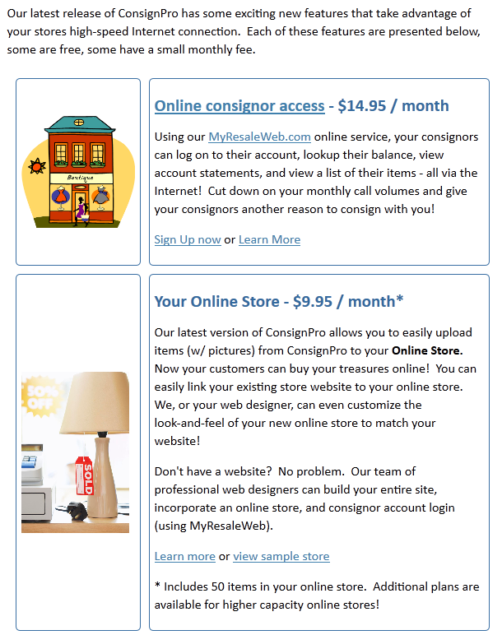
Online features, continued:
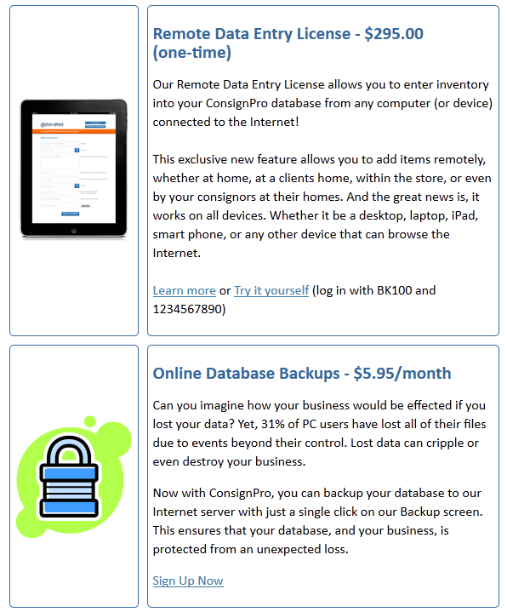

To learn more about or order any of these online features, visit http://www.consignpro.com/cponline.php or call (888) 721-9767.

Logging On/Off and Registration

Before using ConsignPro, you must first log on. The log on screen prevents unauthorized users from using the ConsignPro system.

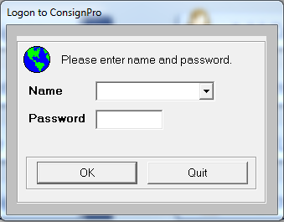

Use the arrow to the right of the “Name” box to select the user that you would like to log on as. Next, type your password in the password box and click on “OK”.

Note: Your initial log on name is “New” and password is “consign”. Log on names and passwords can be changed on the Employee screen. For more information on passwords, see the Employees section of this guide.

Note: ConsignPro has a “training mode”. If you login with a password of “train1”, no information that you enter will be saved to the database. This could be useful when training new employees.

Quit: The Quit button will shut-down the ConsignPro system. As a rule you should exit ConsignPro using the “Exit” button from the Main Menu. This will cause the “shutdown options” screen to appear and also activate daily maintenance processes such as database backups.

Note: The log on screen can be completely bypassed by un-checking the “Show Login Screen” checkbox on the CP Settings screen, see the Maintain Store section of this guide.

Ready to register? See next page.
Registering your Copy of ConsignPro

Registration unlocks ConsignPro for full use. All our software is shipped in “demo” mode, when you are ready to unlock your copy, just give us a call.

- Go to the ConsignPro log on screen and click on the “Register Now” button.
- Note your registration number that appears on the small screen.

At this point, you will need to call (305) 535-0959 or e-mail support@consignpro.com for your ConsignPro registration password. After you enter in the password and click the register button you will have a fully functioning copy of ConsignPro.

Connecting your new hardware

Please refer to the section in this guide named “ConsignPro POS Connections Guide” (page 128) for instructions on connecting your new equipment to your computer and configuring ConsignPro to use it.

Networking ConsignPro

If you’ve purchased a network license of ConsignPro, please visit our networking instructions web page at: http://www.consignpro.com/network.php

Setting up Online Services

If you purchased our MyResaleWeb.com, Online Store Builder, Database Backup, or Remote Data Loader services, follow the instructions in the setup email that you received to turn on those services.

Main Menu

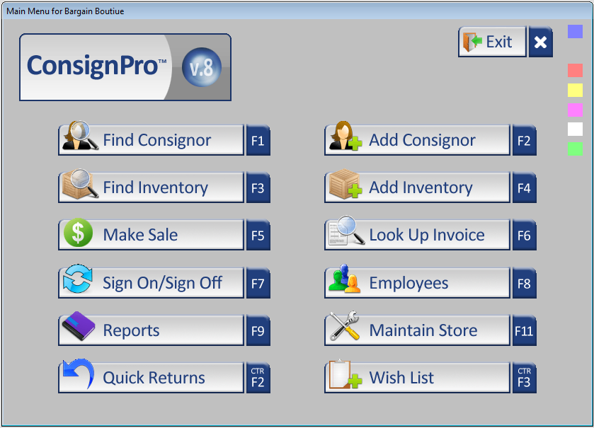

Above you will notice the ConsignPro “Main Menu”. The main menu is the starting point for all of the screens in the ConsignPro system. Let’s take a second and review the major functions within ConsignPro. All buttons can be either clicked with the mouse or selected using the function keys shown below.

F1 - Find Consignor: This function will allow you to lookup and/or change existing consignor account information. Consignor records can be accessed by either consignor number or by last name. More information on this function can be found in the Find Consignor section of this guide.

F2 - Add Consignor: This function will allow you to add new consignors to the ConsignPro database. ConsignPro tracks basic consignor information including the consignor account balance and related inventory. More information on this function can be found in the Add Consignor section of this guide.

F3 - Find Inventory: This function will allow you to lookup and/or change existing inventory items. Items are accessed by Item Number. More information on this function can be found in the Find Inventory section of this guide.

Note: Items relating to a particular consignor can also be found by first looking up the consignor, and then clicking on the “View Items” button on the consignor screen.

Note: If you are looking for an item but don’t have the item number, you can use the “Inventory Lookup Report” on the Reports screen.

F4 - Add Inventory: This function will allow you to add new inventory to the ConsignPro database. ConsignPro tracks inventory information such as: Type, Description, Size, Color, Price, and Status. More information on this function can be found in the Add Inventory section of this guide.

F5 - Make Sale: This feature allows you to sell inventory. The screen can accept either typed or scanned item numbers. Sale information is then calculated including sales tax, discounts, or store credits which a customer may use. A printed sales receipt completes the sale. More information on this function can be found in the Make Sale section of this guide.

F6 - Lookup Invoice: This feature allows you to lookup and/or void items which were part of a previous sale. Invoices can be accessed by either the invoice number (if you know it), or by invoice date using a handy pop-up calendar! More information on this function can be found in the Lookup Invoice section of this guide.

F7 - Signon / Signoff: This feature allows multiple salespersons to quickly log onto and off of the ConsignPro system. Sales and other account activity is tracked in ConsignPro by salesperson. You can also set different permission levels for each employee – this is done on the Employees screen

F8 - Employees: This feature allows you to lookup, change, add, or delete employees to the ConsignPro database. ConsignPro tracks basic employee information and also accepts a password for each employee you set up. The functions an employee can perform in ConsignPro can be limited using this screen. More information on this function can be found in the Employees section of this guide.

F9 - Reports: This feature allows you to access several pre-defined reports from the ConsignPro system. Reports include inventory, sales, income statements, markdown, layaway, payouts, and address, tag, and label printing. Reports can be printed either to the screen or to any attached printer. More information on this function can be found in the Reports section of this guide.

F11 - Maintain Store: This feature allows you to enter in basic store information and information about your store’s policies including: tax rate, split rate, and markdown information. Consignor checks, list maintenance, and ConsignPro settings are also available from this screen. More information on this function can be found in Maintain Store section of this guide.

Ctrl + F2 - Quick Returns: This feature allows you to quickly change the status of inventory items from “Available” or “Store” to either “Returned”, “Donated”, “Store”, ”Missing”, “Damaged”, or “Expired”. You can also use this feature to “re-consign” an item. More information on this function can be found in the Quick Returns section of this guide.

Ctrl + F3 - Wish List: Store owners can use the Wish List function to input items that a customer is looking for. When the item is entered into inventory, the Wish List will report the match on our Wish List Report. More information on the Wish List can be found in the Wish List section of this guide.

Ctrl + F1 - Exit: This button will cause you to exit the ConsignPro system and enter into “Shutdown Options”. More information on exiting and shutdown can be found in the Shutdown section of this guide.

Hint: The File menu also lists all shortcut keys used to access screens off of the main menu.

Main Menu – Menu
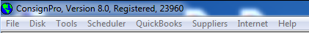

Above the “Main Menu” you will see a menu of options that provide either shortcuts to menu keys or additional features. Each of the menu options (File, Disk, Tools, Scheduler, QuickBooks, Suppliers, Internet, and Help) will be described next.

File – The “File” sub-menu provides shortcuts to each of the buttons already found on the main menu. Use “New” to add a new consignor, inventory item, customer data, or to make a new sale. “Open” retrieves existing data on consignors, inventory items, past sales, employees, or store information. Other options allow you access to our Reports, Signon, or Shutdown screens. Again, using the buttons found on the “Main Menu” can access most of these functions.

Disk – The “Disk” sub-menu allows you to either backup your ConsignPro database or restore a previously backed up copy from disk. Backup Tips and Suggestions can be found under “Backup Tips”.

Info on Backups
While your database is usually backed-up during Shutdown processing when you exit the system, you can backup your database file throughout the day – at any time – using the Disk / Backup Database option. To backup your database, simply select the DRIVE letter you’d like to backup to (D, E, F, etc) and then click the “Backup DB” button.

We recommend backing up to a flash drive or memory key. This is the least expensive and best method for backing up your database file. We do not support backing up to CD’s in ConsignPro. You can also backup your data to the ConsignPro corporate server via your Internet connection. Contact us for details on this option.

Info on Restore
To restore your database from a disk, use the Disk / “Restore old database” function. This will move the database file (either consign.bak OR consign.zip) from your flash drive to the computer. This is especially useful for moving the database from home to work, or vice-versa. You should not “practice” doing restores. Use this feature only if your system has crashed and you need to recover OR if you are working between home and the store.

Note: More information can be found at: www.consignpro.com/backup.php

Tools – The “Tools” sub-menu allows you to “Apply consignor fees”, “Layaways”, “Delete Invoices”, “Delete inventory”, “Physical Inventory Count”, “Post cleared checks”, “Validate Accounts”, “Export email addresses”, “Export consignor data”, “Undo Markdowns”, “Check online listings”, “Balance Cash Drawer”, “View activity log” or “View usage log”. Each function will be described in detail next.

Apply consignor fees:
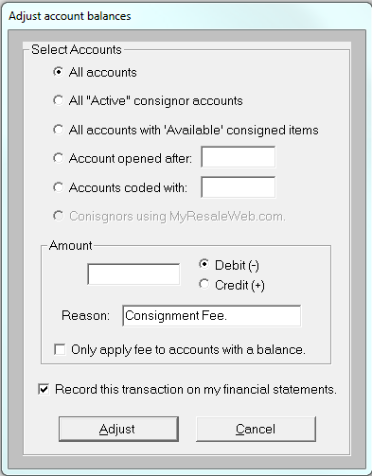

You can apply either debits (subtract money from consignor accounts) or credits (add money) to a group of consignor’s accounts by using this feature. This could be particularly handy if you, for example, always charge an annual account maintenance fee to all active accounts on the first day of the year. Other reasons to globally add to or subtract from consignor account balances also exist depending on your store’s policies.

This transaction will appear on the Account Activity statement with the reason that is typed into the “Reason” box. If an account has a zero balance and you use this feature to debit the account, the resulting account balance will be negative.

You can elect to debit or credit either a) all accounts, b) active accounts, c) accounts with consigned items on them, d) accounts opened after a particular date, e) all accounts coded with a certain “consignor code”, or f) consignors who use MyResaleWeb.com (our online consignor account lookup service).

Active accounts are those accounts where the “Active” checkbox is checked on the “Find Consignor” screen. The “Opened Date” also appears on the “Find Consignor” screen, as does the consignor “Code” field.

If you wanted to subtract $4.00 from every account you would simply type 4.00 into the Amount field, click Debit, enter your Reason, and click the “Adjust” button. ConsignPro will ask you to confirm your choice and then continue to update the accounts you specified.

If there is a check in the “Record this transaction…” checkbox, the credit or debit to the consignor account will appear on the Sales Activity Report and Income Statement as either store income or as an expense.

If there is a check in “Only apply fee to accounts with a balance”, the system won’t debit money from consignor’s accounts unless they have enough money to cover the deduction (ie. the account won’t go negative).

Some store owners choose to charge their consignors for using the MyResaleWeb.com online website. If so, you should check the “Upload select accounts” box on the MyResaleWeb setup screen. Then, you can charge only those consignors by using this screen.

There is currently no way to setup a recurring consignor charge or fee in ConsignPro. If you’d like to do this, you must use this screen each time (ie. monthly) to deduct monies.

Note: Once this process has been performed, there is no way to undo it so be careful!

Layaways

Clicking the “Layaways” option under tools presents the following screen that allows you to perform functions on existing layaways. These functions will be described next, but are presented again in this guide under “Make Sale”.

Note: To initially PUT an item on Layaway you would use the “Make Sale” screen (L & item number) rather than this screen. This process is described in detail in the Make Sale portion of this User Guide.

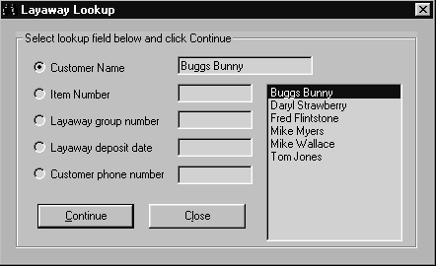
You can lookup and work on an existing layaway by knowing the customer name, item number, layaway group number, original deposit date, or customer phone number. A handy list of all the customers who have items on layaway makes using this screen a snap.

After you have selected the criteria you would like to use (in this case we selected Buggs Bunny from our list of names), click the “Continue” button to see layaway details, make additional deposits, or print a layaway report. “Close” will return you to the Main Menu.

Clicking the Continue button presents the Layaway Details screen (for Buggs Bunny), as shown next:

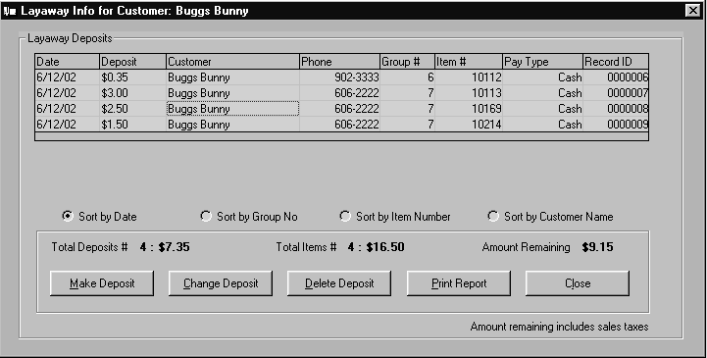
In this example, Buggs Bunny has 4 items on layaway with total selling prices of $16.50. Four deposits have been received totaling $7.35 leaving an amount remaining of $9.15 (which includes applicable sales taxes). As you can see, ConsignPro details each individual layaway deposit so you’ll always have an accurate record of each deposit amount and the date it was applied. Deposits can be sorted by Date, Group Number, Item Number, or Customer Name by clicking on the “radio buttons” next to each parameter.

This screen is also used to change, remove, or make additional layaway deposits. Each of the buttons on the screen will be described next.

Make Deposit – This button is used to apply additional money to an item (or group of items) that is on layaway. If you would like to apply money to a single layaway item, first click on the Item Number you’d like to work with (in the 6th column) and then click “Make Deposit”. If you would like to apply money to a GROUP of items at once, first click on the Group Number you’d like to work with (in the 5th column) and then click “Make Deposit”.

When you click the Make Deposit button, the following screen appears. We have elected to add a $2 cash deposit to item #10113. The additional deposit screen is shown next.

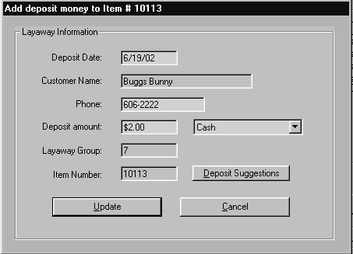

After you enter in the “Deposit amount” and select the payment type, click the “Update” button. This will commit the transaction and return you to the deposit detail screen. Clicking the “Deposit Suggestions” button will bring up a screen with suggestions for additional deposit amounts. Cancel will return you to the previous screen without adding deposit money.

Change Deposit – The “Change Deposit” button is used to change the money amount on an existing layaway deposit. You must first click on the “Deposit” that you would like to change (column 2). Using this button will display a screen (shown above) which will allow you to change the deposit date, customer name, phone number, deposit amount, and/or payment type.

Note: When you add a new deposit, or change the money amount on an existing deposit, ConsignPro will automatically write a new invoice record which will appear on the end of day Sales Activity Report and Income Statements as either additional revenue or a refund.

Delete Deposit – This button is used to remove an existing layaway deposit. Before clicking this button you must select the deposit you’d like to remove by first clicking on the “Deposit” (column 2). When you delete a deposit the following screen appears and allows you to tell ConsignPro what to do with the money.

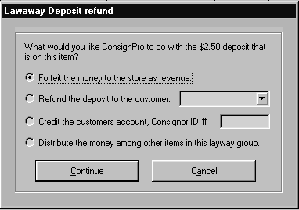
In this case, we’ve elected to forfeit the deposit as revenue for the store. Other options include refunding the deposit to the customer (a payment type is required), crediting the money back to the customer account (if they are also a consignor), or distributing the deposit among other items on the group (if there are other items on the group).

Select what you’d like to do with the deposit amount and then click the “Continue” button to process the transaction. Click the “Cancel” button if you’ve decided you do not want to remove the deposit from the system.

Print Report – This button will create a “Layaway Report” for the layaway deposits that appear on the deposit details screen. This report will only print your report printer and not to the screen.

Close – The Close button returns you to the Layaway selection window.

Delete Invoices

The Delete Invoices window is used to completely remove a sale from the database. This screen should NOT be used for typical customer returns. Instead, the “Lookup Invoice” screen should be used as it reverses the accounting and debits the consignors account. More information on customer returns can be found under “Lookup Invoice” in this guide.

To remove a single invoice completely you can enter in the invoice number and click “Process Delete”. This will remove the invoice from the database as if the sale never occurred. If you want to remove ALL invoices from the database (there is seldom a reason where this makes sense) call us at 305.535.0959 and we can provide the password. We’ve password protected this because of its “destructive” nature. Only the registered user of ConsignPro may call for this password.

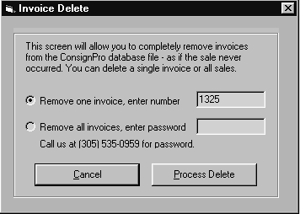

Delete Inventory
This function can be used to remove really old items from the system. The screen is below and will be described next.

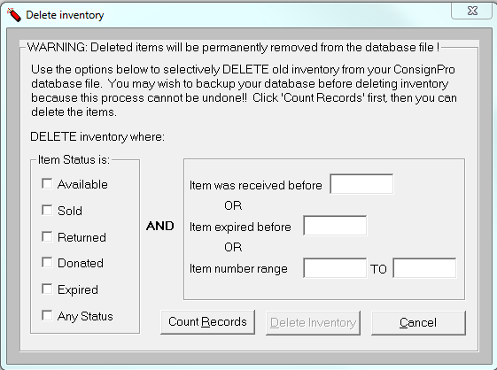

To use this screen, first select the status of the items you’d like to delete and then you must select the second criteria to the right (one of the three). Both the left side of the screen and the right side must be true or the item will not be deleted.

After you have selected the items, click the Count Records button. This will count the number of items that meet your “criteria”. If you agree the number sounds about right, the Delete Inventory button can be clicked. If not, you can revise your criteria and Count Records again.

Note: This function can NOT be undone so delete carefully. Also, we have features on the Shutdown screen (Remove from database…) that will remove old items from the database file automatically. Most store owners do not find it necessary to use this screen.

Physical Inventory

Clicking “Physical Inventory Count” will present the following screen.

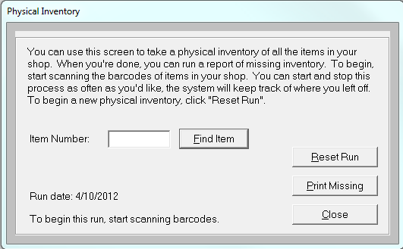

You can use this screen to find items that are missing (lost, stolen, etc). To do this, you must scan the barcode or type in the item number for each item in your shop. When completed, you can click the “Print Missing” button to display a report of missing inventory.

You can start and stop this process as often as you need to. Once you’re satisfied with the run, nothing needs to be done until you need to run physical inventory again. At that point, click Reset Run and you can begin scanning items into the new run.

Note: Some store owners choose to run physical inventory once a year and provide the resulting report to their insurance company to make up for inventory lost due to theft.

Post Cleared Checks

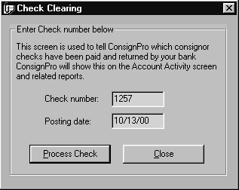Clicking “Post cleared checks” presents the following screen that is described next.

The “Check Clearing” screen is used, in conjunction with your bank statement, to tell the system which consignor checks have been paid by your bank. To post a cleared check, simply enter the check number from your bank statement and click the “Process Check” button. ConsignPro will then update the consignors account activity record and record the date that the check cleared. This date will appear in the “Item #” column on the “Account Activity” screen for the consignor who was paid.

Note: While this process is completely optional, some store owners like a record of which checks were paid by their bank and the date they were paid. This often helps when a customer claims they never received their check. The store owner can then cheerfully reply, “Not only were you paid, but you cashed the check on {some date}”.

Validate accounts:

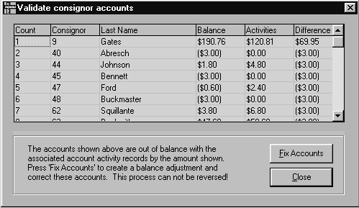

The “Validate accounts” function allows you to compare the consignor account balance on the “Find Consignor” screen against the totals of that consignors account activity records. The two should always be in balance but can be out-of-balance due to employees changing a consignor’s balance but not writing an account activity record OR deleting an account activity record without adjusting the balance.

This screen that appears will show only the accounts that are out-of-balance. Clicking the “Fix Accounts” button will put the accounts listed back in balance by writing an account activity “Balance Adjustment” record to each consignor account where a discrepancy exists. When complete, the consignor account balance will now equal the sum of all account activity records – as it should. You can test this by re-running “Validate accounts” from the Tools menu and verifying that no accounts appear in the listing.

Note: Before you click Fix Accounts, you should review the accounts that are out of balance and determine what the correct balance should be. ConsignPro assumes it is the Account Balance on the Find Consignor screen. If this is not the case, you should call us to adjust individual consignor accounts.

Export E-mail addresses

This function allows you to export both customer and consignor email addresses to two text files (ecustomr.txt and econsign.txt). Customer e-mail addresses are exported to C:\Program Files (x86)\ConsignPro\ecustomr.txt. Consignor e-mail addresses are exported to C:\Program Files (x86)\ConsignPro\econsign.txt. Every time this feature is run, it will replace those files with newer files.

Some store owners choose to use these files and import the addresses into a email marketing program such as www.ConstantContact.com (or similar).

You can also use the Internet / “E-mail all consignors” function to send e-mail directly from ConsignPro. This feature is described more under the “Internet” menu on the next few pages.

Export consignor data
This feature is useful for exporting your consignor’s names and addresses to a “comma-delimited” file to send to a mail-house for a mailing. When you use this feature, ConsignPro will create a file (C:\Program Files\ConsignPro\consignr.csv) that you can then either attach to an e-mail note or put onto a disk / flash drive / etc to give to the mail house company.

Undo Markdowns

This feature was added to ConsignPro so that “accidental” time-period markdowns could be reversed. Using this feature will undo all time-period markdowns and return all available inventory to their “original prices”. The system prompts you with several “Are you sure?” messages because this cannot be reversed if performed!

To turn off time-period markdowns completely, go to the Maintain Store screen, Store Terms page and make all 6 markdown / split boxes zero. Also, remove the check from the “Markdown Inventory” checkbox on the Shutdown screen when you exit the program.

Check online listings

ConsignPro can now upload items to your own online store by subscribing to our Online Store Builder service. This feature, starting at $9.95 / month can feature the items you choose in an online store with your store name, address and contact information on it. For more information on this feature, visit: www.consignpro.com/onlstore.php

The check online listings tool will validate all of the online listings you’ve created to see if they are ready to be uploaded. This tool is mostly used in conjunction with our Support team to help you solve a problem you may be having with your online store.

Balance Cash Drawer

The following screen appears when you select this menu option:

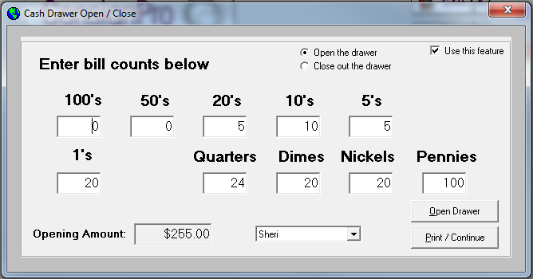

This screen is available when the electronic cash drawer is connected to the Star receipt printer. It allows you, each morning, to enter in the bills and coins in the cash drawer when you “open” your day and when you “close” your day. A receipt for each will print on the Star receipt printer. This makes it simple to balance your drawer at the beginning and end of each day.

If you choose not to use this feature, remove the check from “Use this feature” and it won’t appear until that box is checked again.

Customer Rewards

Customer rewards (aka “customer loyalty program”) can be setup on the Maintain Store screen, under Store Terms, using the “Customer Rewards” button. Once that program is setup, customers will automatically accrue rewards as they shop in your store. If you ever need to adjust the reward for any customer, the screen below can be used to do so.

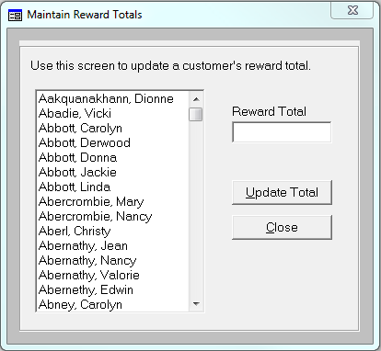

To change a reward total, simply click on the customer, the reward will appear, change it, and click the “Update Total” button.

View activity log

A special “log file” was added to ConsignPro in an attempt to capture possible employee theft from store owners. The log file captures the following questionable transactions:

- An employee rings up a sale but cancels the sale rather than completing it – perhaps putting the “Amount Due” into their pocket rather than the cash drawer!
- An employee deletes an “account activity” record from the Account Activity window. This could be an attempt to remove history from a consignor’s account.
- An employee changes a consignor’s account balance but does not instruct ConsignPro to write an account activity record to record the reason for the balance change.
- An employee deletes an inventory item from the system.

Note: Using the Employee screen you can set the permission level for each employee that you add to the system. Permission levels can be used to limit the types of transactions that an employee can perform within ConsignPro – thereby limiting the amount of devious or destructive transactions that can be performed. More information on this is under Employees in this User Guide.

View usage log

The usage file tracks the employees that log in and out of the system throughout the day with the time and employee name. It also includes a record of anytime the system is started or shut down. You can turn off this logging on the CustomizeCP screen, under the Store Settings tab.

Scheduler

Clicking this button brings up our appointment scheduler.

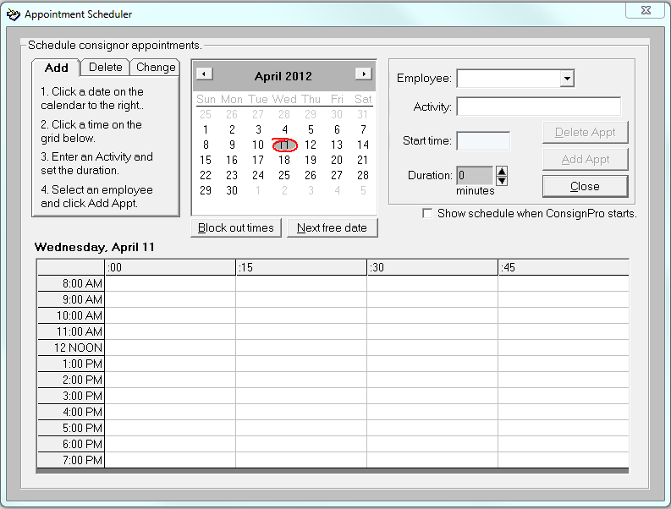

This tool is designed to schedule consignor appointments but can be used for just about anything – including scheduling employees or other appointments you may have during the day.

To add a new appointment, first click on the date on the calendar. Then click on the grid to select the start time. Next, type in the “Activity” or person you’re scheduling, and then set the Duration box. When done, click the Add Appt button. If the appointment is being assigned to an employee, you can select the Employee from the drop down list.

To delete an appointment, first click the date on the calendar that has the appointment you’d like to delete. Next, click on the activity in the grid. Lastly, click the Delete Appt button.

To change an appointment you must delete the wrong appointment and then add it back correctly.

You can also block out times when you will not accept appointments (i.e. shop is closed, lunch break, etc). To block out times, click “Block out times”. Then select the times you’re not available by clicking the blocks in the grid below. Then click Save Changes. Times you block out apply to ALL days – as of this printing, you cannot set different block-out times on individual days.

The “Next free date” button can be used to find the next available appointment time and bring you to that date/time automatically.

The “Show schedule when ConsignPro starts” checkbox can be used to automatically display the schedule when you start ConsignPro in the morning.

The appointment schedule can also be printed on the Reports screen under the Other Reports tab. More information is given in the Reports section of this guide.

QuickBooks – This feature allows you to “export” sales data to QuickBooks. There is also a feature to export your consignor check data to QuickBooks. More information on the QuickBooks export feature is found in the QuickBooks section of this guide.

Suppliers – This is simply a quick link to the phone numbers of the suppliers we have setup special deals with for our shop owners. We encourage you to use these suppliers as you can save money by doing so. Please let them know that you’re using ConsignPro when you call to be included in our group rates.

Internet – This option allows you to visit several of our helpful web pages, send us an e-mail note, send e-mail to all of your consignors, specific consignors, or your customers. All of these options rely on a broadband (cable or DSL) Internet connection. If you do not have one, these features won’t help you very much. If you do, keep reading.

When you click any of the e-mail options, you will be directed to our “ConsignPro Post Office” screen. This screen will be fully described in the Find Consignor section of this guide because it can also be accessed from that screen. In short, you can send e-mail to all of your consignors or customers using this option – once it is configured correctly.

Help – The Help sub menu provides information about registering ConsignPro, view release notes, POS hardware options that will work with the system, credit card processing, your license agreement, and the obligatory “About” screen.

Find Consignor

Finding and adding a consignor both use the same screen in ConsignPro but you access the screen using two buttons; one for add, one for find. Because both functions use the same screen, we will present both here together.

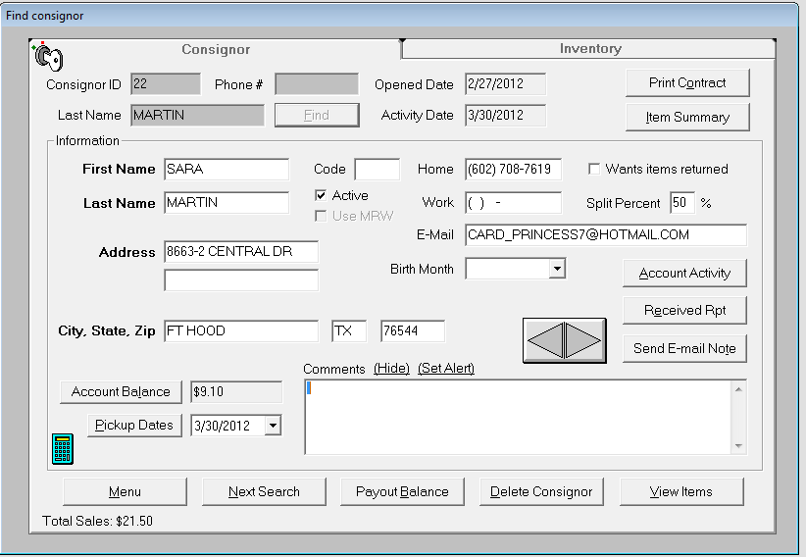

Above you will notice a sample consignor screen. Take a moment to review the type of information maintained on this screen.

Finding an Existing Consignor

- Either enter the consignor number in the “Consignor ID” field and click on “Find”, or,
- Start typing in the Last Name lookup box. ConsignPro will automatically narrow down your search with each key that you press, until you find the name you are looking for, or,
- Type in either of the consignor’s phone numbers (home or work) and, with any of these choices click the Find button or hit Enter.
As you can see, ConsignPro returns basic consignor information from the database. Most fields can be changed. Bold fields are required and cannot be left blank. Also, ConsignPro will automatically capitalize the using proper name rules. (ex. “miami beach” becomes “Miami Beach” when you tab off of the City field!)
Next we will provide a brief description of each field and button on the consignor screen and how it is used in ConsignPro.

Consignor Fields

Lookup Fields

Consignor ID - Used in conjunction with the “Find” key to lookup a consignor.
Last Name - Used in conjunction with the “Find” key to lookup a consignor.
Phone # - Used in conjunction with the “Find” key to lookup a consignor.

Other Fields
Opened Date - Date the consignor was first added to the ConsignPro system. This date is set by the system and cannot be changed.
Activity Date – Date the last activity on this consignors account occurred. Examples include: an item was added, an item was sold, a payout was done, etc.
First Name - Consignor’s first name. (required)
Last Name - Consignor’s last name. (required)
Address - Consignor’s home address. (required)
City, State, Zip - Consignor’s home city, state, and 5-digit zip code. A comma is not required after City or a period after state abbreviation. When adding a consignor, this information defaults to the information on the Maintain Store screen but can be easily changed. (required)
Home Phone & Work Phone - Consignor’s phone numbers. (optional)
Email address – Consignors e-mail address.
Code – You can “code” a consignor and then restrict check printing to just that group of consignors. For example, if you “code” a consignor as “ABCD”, you can print checks for just those consignors with the code of “ABCD”. You can also use the code field when applying consignor fees via the “Tools” menu option. (optional)
Active - Checked if the account is active. ConsignPro will only print address labels for active consignor accounts only.
Use MRW – If you subscribe to our online consignor lookup service, you can select which consignors can use the service. Some store owners choose to charge for the service, others simply allow all consignors to access their accounts online. More info can be found at www.consignpro.com/mrwinfo.php
Wants items returned – Checked if the consignor wants his or her items back at the end of the consignment period. This consignor option controls the “Return to Consignor” checkbox on the “Add Inventory” screen and the printing of the word “Return” on inventory tags or labels. The default for this box is can be set on the “Maintain Store” screen on the “Store Terms” tab. The checkbox reads “Return consigned items”.
Split Percent. - The default split percentage for the consignor. This field automatically defaults to 100% minus the store percentage, but can be changed to any split percentage. When an item is added for this consignor, the consignor percent for the item is defaulted to the Split Percent. The store cut percentage is set on the “Maintain Store” screen – Store Terms tab.
E-mail – The consignors email address.
Birth Month – The month the consignor was born. You can print mailing labels for consignors born in July (for example) so that you can send out birthday cards!
Account Balance - The consignor’s account balance. This field is protected but can be manually changed by clicking the “Account Balance” button if adjustments need to be made. ConsignPro will automatically credit this balance during sales and debit it during account pay outs, check printing, or if a portion of the balance is used to pay for a sale.
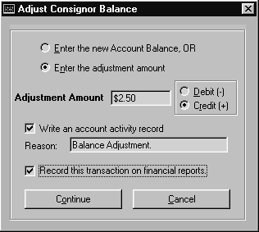If you click the “Account Balance” button, the following adjustment screen appears:
On this screen, you can elect to either type in the NEW consignor balance (which would replace the old account balance) OR enter in the adjustment amount (as a debit or a credit).
In our example, we’ve chosen to increase the consignor balance by $2.50, write an account activity record to record this transaction, and record this transaction on our financial statements.
Note: You should always write an activity record to record changes to a consignors account balance as this will keep the Activity window in balance with the Account Balance on the Find Consignor screen. The Reason that you include will appear on consignor statements!
Note: If you change a consignor’s balance, you are either taking money away or giving money to a consignor. This would typically result in either your store “making” more money or “losing” money (as the obligation has changed). As a result, you should be recording this type of transaction on financial statements by placing a check in that box – as we have done in our example, however the choice is yours.
Clicking the “Continue” button will adjust the balance. Clicking “Cancel” will close the window without adjusting the balance.
Pickup Date – This field contains the pickup date (or dates) of consigned items that are still Available in the system. You can use the drop-down list to see all the dates. Click the “Pickup Date” button to refresh the dates as changes could have occurred and they may not be accurate. The date is maintained by the system and cannot be changed.
Comments - This field is used to enter any “free-form” text that you’d like tied to a consignor (ex. “Do not accept checks”). This field has special meaning for both “Store” and “Vendor” items which will be discussed in “Add Inventory”. Comments can be “hidden” on the screen by clicking the “Hide” button – this can deter nosy consignors from seeing less than complimentary notes on their account!
Set Alert – This can be clicked to set an alert to pop-up anytime this consignor’s account is accessed. It is a simple reminder than can then be removed or kept for the next lookup on this account.

Consignor Buttons

Find - Used to find a consignor and return his/her information to the screen. Either a consignor ID, last name, or phone number must be entered before this button is available.
Account Activity - Used to bring up a screen showing consignor account activity. This screen can also be printed to serve as a report. Below is a sample screen showing account activity.
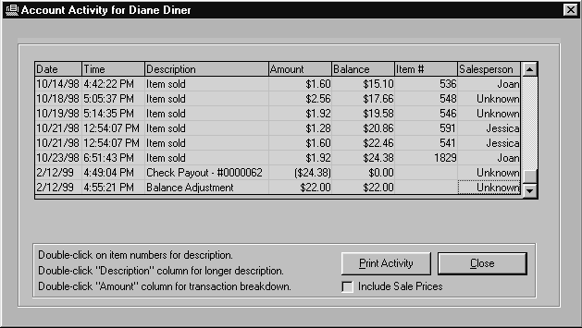
As you will notice, this screen shows all activity that has affected this consignor’s account balance. The transaction amount is in the “Amount” column and the running balance is shown in the “Balance” column. An item number will appear if the balance change was the result of a sale or return.
Double-clicking on the item number will give you a quick description of the item that was sold or returned.
Double-clicking the Amount on any sale transaction will give you a more complete breakdown of how the amount was calculated by ConsignPro.
Double-clicking the “check number” will allow you to change the check number.
Store owners should pay special attention to any “Balance Adjustment!” line because those were changes keyed to the balance field by a salesperson and not by ConsignPro. The “Balance Adjustment Report” on the Reports screen will show you all balance adjustments made on the system after any date that you choose. More information on this report can be found in Reports.
The “Print Activity” button will print account activity to your default printer. A “begin date” and an “end date” can be used to print only account activity between certain dates.
The “Include Sale Prices” checkbox will include the amount the item was sold for on the report when printed. Some store owners want to show consignors what an item sold for, others choose to only show the consignor what their split amount was for the item. ConsignPro gives you the flexibility to do either.
“Close” returns you to the consignor screen.

Print Contract - Clicking this button will print a consignor contract to your printer. Contract wording must be typed into a special box on the “Maintain Store” screen. More information on contract wording can be found in Maintain Store.
Item Summary – This button is a snapshot of the consignor item totals grouped by item status. It gives a breakdown on “Available”, “Sold”, “Donated”, “Returned”, “Expired”, “Moved to Store”, and “Layaway” items. For more detailed information about a consignors items, click the “View Items” button on this screen.
Received Report - This button will print out any items added for the current consignor. This report serves as a printed inventory receipt for consignors after logging in new items through the Add Inventory screen. The system will ask for the date the items were added, the current date is the default. If no items are found for that date, the system will ask if you’d like to print a “Drop-off Receipt” rather than a Received Report. One-half of the Dropoff Receipt usually is given to the consignor, the other half with the items dropped off.
ConsignPro will prompt you for the number of copies you’d like to print.
Menu - Returns you to the ConsignPro main menu.
Next Search - This button resets the screen and allows you to lookup a different consignor account.
Payout Balance - This button is used to pay out all, or a portion of, a consignors account balance and makes an entry on the activity screen. The payout window (shown next) allows you to tell the system how much money to pay out. You can also enter a “Payout Thru” date and the system will calculate the correct pay out amount as of that date.
The Payout Balance button can be used for cash pay outs and printing individual consignor checks. More information on printing batches of checks can be found on the Store screen and is discussed in Maintain Store.
Note: To print an individual consignor check, click the “Print consignor check” checkbox on the screen that is shown below. This option is not available if you are printing 3 checks per page, as it would waste checks. This screen is shown next.
Note: A special “Payout Report” can also be printed during this process. This report is generally signed by the consignor to indicate that they have received the payout. To print this report, click the “Print Payout Report” on the following screen. If you have a 3” receipt printer attached to the computer, ConsignPro will print the payout receipt on that printer, if not; it will print on a full-page.

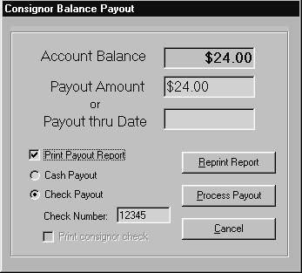
To use this screen, either enter the correct “Payout Amount” OR type in a “Payout thru Date” and press the Tab key. The system will then show you the Payout Amount as of that date. If you are printing a check, enter in the check number and the system will record it.
In this example, we’ve chosen to payout the entire $24 balance using a handwritten check, number 12345 and print a Payout Report to record this transaction on paper.
The “Reprint Report” button can be used to re-print the payout report for any consignor payouts done on the same day. This might be necessary in the event of a printer jam or malfunction.
After you have completed entering the payout amount and necessary options, click the “Process Payout” button to process the transaction. To close the screen without paying the consignor, click the “Cancel” button.
If you routinely enter in a Payout Thru date that is, for example, 7 days ago, you can set this once on the CustomizeCP screen. The box on that screen is “Quote consignor balances as of ____ days ago”. In my example, you could enter 7 in that box and the date on this screen will fill automatically and the balance will be re-calculated automatically.

Delete Consignor - This button will remove the consignor and all related inventory and account activity from the ConsignPro database. This button is only shown if the employee that is logged on has the “Delete consignors” option. This option is discussed in the “Employees” section.
View Items - This button will display all inventory items associated with the current consignor. “Previous”, “Next”, and “List View” buttons allow you to “scroll” through items belonging to that consignor. The inventory screen will be discussed in more detail in the Find Inventory section of this guide.
Left & Right Arrows – You can scroll through consignor records by clicking either the right or left arrow buttons. Clicking the right button will find the next consignor id number, clicking the left will find the previous consignor id number.
Calculator icon – The calculator button on the lower left corner of the screen will activate your Windows calculator. You can use the calculator to manually calculate an adjustment to a consignors account balance before you type in the new amount.
Lock icon – In the top right corner of the screen you will notice a key/lock. Store owners can use this to prevent non-owners or managers from looking up that consignor account. This can be useful if you have a family or owner account that accumulates money that you may not want some employees to see.
Send E-mail Note – If the consignor has an e-mail address, you can click this button to send the consignor an e-mail note directly from ConsignPro. This new screen is discussed next.
Below is the ConsignPro Post Office screen.
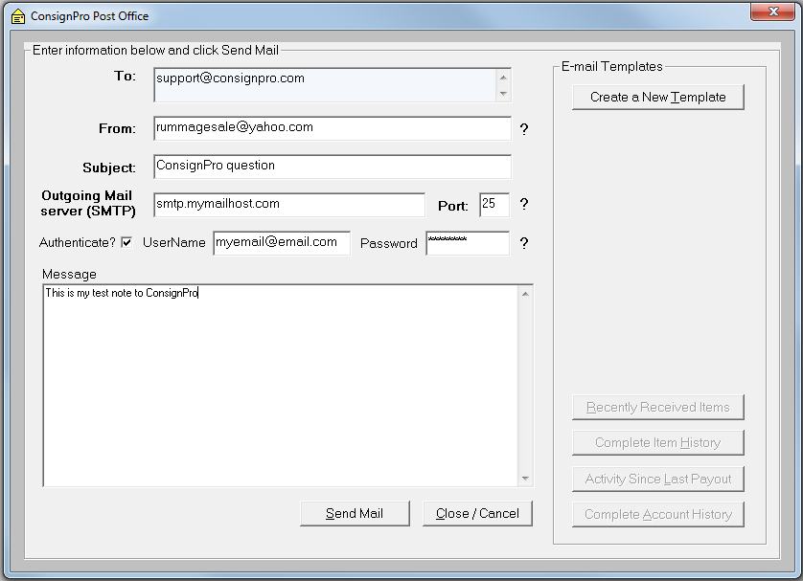
This screen is used to send e-mail to your consignors. Before you use this screen you need to enter the following fields:
To: Filled in automatically with the consignors e-mail address.
From: Your complete e-mail address.
Subject: E-mail subject.
Outgoing Mail server / Port number: Contact your Internet Service Provider to find out your outgoing mail server name and port number. Ask your ISP if their outgoing mail server requires authentication. If so, check the Authentication box and type in your user name (usually the part to the left of the @ sign in your e-mail address) and your e-mail password.

E-Mail templates: We have created 6 templates that you see on the screen. Creating a template of your own is fairly easy.

- Open Notepad on your computer (usually Start / Programs / Accessories / Notepad).
- Type your e-mail message into Notepad.
- Click the “X” to close the window, when prompted to Save, click Yes.
- The save window appears. From the “Look In” box at the top, select your Local Disk (C) drive. Open the Program Files folder by double-clicking. Open the ConsignPro folder by double-clicking. Type in a name to save the file with (ex. “Welcome new consignor”, “Happy Birthday”, etc) – what you type in will be what you see for a template name in ConsignPro so be descriptive.
- Repeat the above steps for each template you’d like to create. When you close and re-open the e-mail window, your templates should appear. You can have a total of 9 templates.

To edit an existing template, simply click the template radio button and then click the “Edit template” button. ConsignPro will open the template for you. When done, save your changes, it’s that simple.

To delete a template, use the My Computer icon to find the template in the C:\Program Files\ConsignPro folder. Right click on it and select Delete.

Using e-mail templates
Once a user-defined template is created, you simply select the radio button next to it. ConsignPro will paste the message into the e-mail for you automatically.
We have created four system templates for you. You access them using the four buttons on in the template window. These will pre-fill the e-mail note with inventory or account activity information automatically! You can edit the note before sending it but there is no way to edit the actual template – they are hard-coded within ConsignPro.
Sending e-mail to a consignor
Once you have entered the required fields and have a good e-mail note, simply click the Send Mail button. The sending will take 5 to 10 seconds and it should say “Mail Sent”. If you get any other message, check to be sure you mail server, port number, authentication (if required by your ISP), and e-mail “From” address are all correct.

Sending e-mail to all your customers / consignors
Using the Internet option (above the Main Menu) you can create an e-mail note to be sent to all of your consignor or customers. We suggest sending a test e-mail to a single consignor before tackling a group send – this will ensure that your settings are perfect.
ConsignPro will send the e-mails individually so that no consignor will see any other consignors e-mail address. This process could take a considerable amount of time depending on the speed of your ISP mail server and the number of e-mail addresses you have on file. We suggest doing this from the SERVER computer (if you have more than one computer) at the end of the business day.

Adding a new Consignor
When adding a new consignor, the consignor screen appears blank but prompts you with the next available consignor number. Consignor numbers can be manually changed but must contain only numbers and must be unique.
After entering all of the required fields (those with bold headings), click on the “Save Record” button or the “Add Items” button. The “Add Items” button allows you to add items for the new consignor without returning first to the Main Menu.
ConsignPro will prevent you from adding duplicate consignors to the system by searching for the consignor’s name when you Tab off of the Last Name field. If a consignor with the same name is found, the system will warn you before continuing.

Note: The “Save Record” and “Add Items” buttons only work when all required fields on the screen are completed and you Tab off of the Zip Code field.

Note: A consignor must be added before any items can be entered for that consignor. Instructions for adding inventory items can be found in Add Inventory.

Finding or Adding Inventory

Like finding and adding consignors, these inventory topics are presented together because both functions share similar screens.

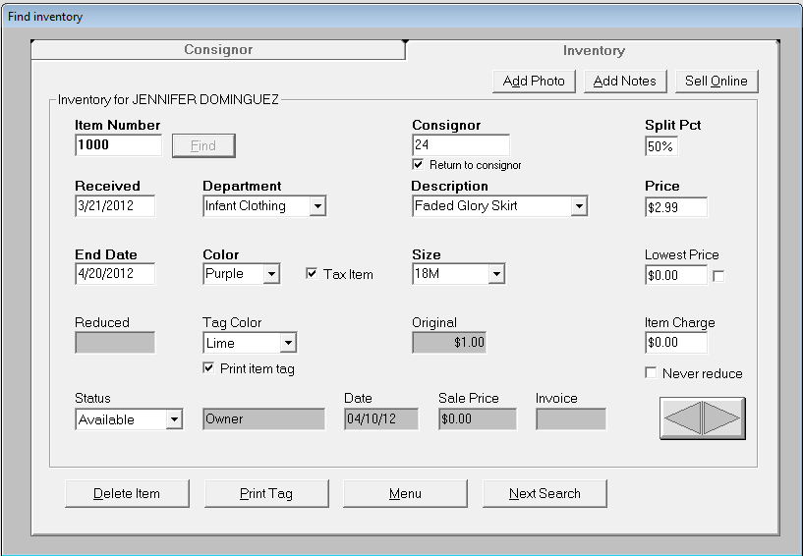

Above you will notice a sample inventory screen. Take a second to review the types of inventory information that ConsignPro maintains. Each will be described next, in detail.

Finding items

- Enter the item number in the “Item Number” field and click on “Find”. The item is returned from the ConsignPro database. In our example, we looked up item number 1000 which is an “Available” item on the database.

Next we will provide a description of each field and button and how it is used (if applicable).

Find Inventory Fields

Item Number - Used in conjunction with the “Find” key to lookup any inventory item. ConsignPro automatically assigns item numbers when you use the Add Inventory button on the Main Menu. Each item number in the system must be unique – that is, there cannot be two items numbered “5” on your database. Our suggestion is to allow ConsignPro to number your inventory items for you and let the system keep track of who owns what. Two reports are available (Received Report and Inventory Lookup Report) to show what items a consignor owns.

Consignor Number - This field displays the consignor number or last name of the consignor who owns or owned the item that is displayed. The consignor name also appears on the “frame” surrounding the inventory information.

Note: When adding new inventory you can either type in the consignor id, if you know it, or start typing the consignor’s last name. A name lookup list will appear and narrow your selection with each letter you press. When you have found the entry, either hit Enter or double-click the correct name.

Return to Consignor - This check box can be checked to show that the consignor wants the item returned if it is not sold. This field will automatically set to the setting on the consignor screen called “Wants items returned”. For example, if you add an item for Bob Jones who had the “Wants items returned” check box check on the consignor screen, the “Return to Consignor” checkbox will be checked for his items. This, of course, can be unchecked or checked for any item you add. The word “Return” will appear on item tickets for items where this check box is checked.

Split Pct - The percentage of the sale that the consignor will receive when this item is sold. This field automatically defaults to the “Cust Pct“ field on the Find Consignor screen. More information on the Cust Pct field can be found in the Find Consignor section of this guide.

Received - The date the item was originally logged into the ConsignPro database. This field is defaulted to the current date but can be changed. If you are using automatic markdowns, this date is used to determine how “old” an item is and when markdowns appear.

Special Feature Note: All dates in ConsignPro can be entered without the slashes. For example, if you key in 050101 (must be six digits), ConsignPro will automatically insert slashes for you when you press Tab to leave the date field.

End Date – This is the date that the consignment period for this item ends. This is automatically set to the items “Received Date” plus the “Return After Days” value on the “Maintain Store” screen. If you choose, ConsignPro will use this field to automatically “move” items to the “Store” account or automatically change an item’s status to “Expired”. Both of these options must be setup on the “Customize CP” screen. More information on these automatic processed can be found in ConsignPro Settings.

Type - The type of inventory item displayed (ex. Men’s Clothing, Furniture, Sporting Goods, etc.) This drop-down list can be changed from the Store screen using List Maintenance. This list can be optional and/or keyed directly to – see List Maintenance.

The “Hold” button next to Type can be used to “set” the Type in the system for a period of time. This is useful if you tend to use one “Type” for multiple consecutive entries.

Description - The description of inventory item displayed (ex. Shirt, Pants, Table, Book, etc.) This drop-down list can be changed from the Maintain Store screen using List Maintenance. This list can be optional and/or keyed directly to – see List Maintenance.

Color - The color of inventory item displayed (ex. Red, Blue, Black, etc.) The drop-down list contents can be changed from the Store screen using List Maintenance. This list can also be keyed to directly using the keyboard and can be optional – see List Maintenance.

Size - The size of inventory item displayed (ex. Small, 40 Regular, 10, etc.) The list contents can be changed from the Store screen using List Maintenance. This list can also be keyed to directly using the keyboard. This list can be optional – see List Maintenance.

Reduced - The date that the item was last marked down by ConsignPro. ConsignPro marks down items using the markdown rules that you establish on the Maintain Store screen. Automatic markdowns are optional. See the Store screen for more information.

Price - The price that you are asking for the item. This field is required. This is also the price that appears on the inventory label or tag. More information on printing inventory labels and tags is found under the Reports or Store section of this guide.

Lowest Price - The minimum acceptable price the consignor will accept for the item. This price should be less than or equal to the Rack Price. ConsignPro prompts you during a sale if you’ve changed the sale price to one less than the Lowest Price. This field is optional.

The “Lowest Price” field is also used as a minimum price during automatic markdown processing. If an item should never be marked down, make the Lowest Price equal to the Price.

Checkbox next to Lowest Price – Use this checkbox to set a “Wholesale Price” for the item. A wholesale price should only be set if you’re splitting the profit made on an item with the consignor. Example: A consignor brings you in an antique lamp and says I bought this lamp for $50 and I’m willing to split with you any money you can get for it in excess of the $50 I paid for it”. If you set the rack price at $75 for the lamp and the “Wholesale Price” at $50, you and the consignor will split the $25 profit made when the lamp sells. How the profit ($25) is split depends on what the “Split Pct” is for the lamp. Not many stores use this option; it was added specifically for stores that do business with “dealers”.

Original Price – If the price of an item ever changes, this field will display the price the item was originally entered as. An item’s price might change if you use our automatic markdown options setup on the Maintain Store screen.

Reduced – The date the item was last marked down by the system if you’re using the time period markdowns on the Maintain Store screen.

Tag Color - You can assign a Tag Color as you add inventory items. Items can be automatically reduced when sold by tag color. You can assign markdown rules for each tag color on the Maintain Store screen by clicking on “Tag Color Markdown”. Tag colors can be added or changed by using the “Maintain Lists” button, also found on the Store screen. This list can also be optional – see List Maintenance.

“Print Item Tag” checkbox – This checkbox determines if a tag will be printed for the item when you print tags on the Reports page. If unchecked, no tag will be printed.

Item Charge - Per-item-charges can be assigned to any inventory item. A per-item-charge is a fee that the consignor pays to the store when an item is sold. Examples of per-item-charges are cleaning, repairs or other consignment fees. This fee is automatically deducted from the consignor split when an item is sold.

Note: Some store owners wish to add money to the tag price when tickets are printing. This is called a “buyers fee” and does not affect the amount the consignor receives for the item. Many confuse buyers’ fees with “Item Charge”. More information on how to setup buyers’ fees can be found on the Maintain Store screen.

Buyers Fee – A buyer’s fee can be automatically added to an items price when a tag or label is printed. The buyer pays the buyer’s fee when the item is sold, but the fee is not split with the consignor nor does it ever appear on any consignor report or statement.

Status - This drop-down list shows the current status of the displayed item. This field determines what actions (sales, markdowns, changes, etc.) can be performed on an inventory item. Status’ are:

- Available - The item can be sold.
- Donated - This item was donated and cannot be sold or changed. (final)
- Returned - The item was returned to the consignor and cannot be sold or changed. (final)
- Sold - The item was previously sold using ConsignPro and cannot be changed. (final)
- Remove Item - This status can be used to delete items from the ConsignPro database.
- Vendor - This status is used for any item that you can sell multiple items using the same item number. Example: You buy a box of candy bars from a vendor and only log in one candy bar for 65 cents as “Vendor” item #2035. You can sell as many #2035 items as you wish during one or multiple sales. The status does not change to 'sold' but remains “Vendor”.
- Layaway - Indicates that an item is on layaway for a customer. To put an item on layaway, sell the item using an “L” before the item number on the Make Sale screen. More information on this is found in the Make Sale section of this guide.
- Store - This status is used for items that the store owns. Example: You buy a table at a garage sale for $25 and log it in as “Store” item # 2122. The Price you assign is $40 and the “Store Cost” of $25 is entered into the “Store Cost” field. ConsignPro then correctly accounts for this sale on both sales and income statement reports.
- Expired - This status can be used to prevent an item that belongs to a consignor from being sold at the end of a consignment period. Expired items must be moved back to “Available” before they can be sold.
- Missing - This status can be used to identify items that cannot be found in the store. Items in missing status can still be sold and you can always run an Inventory Report on all “Missing” items.
- Storage – The item has been placed in storage to be sold at a later time.
- Auction – This status will be set automatically when you add an item and click the Auction Item radio button. You can enter in an auction id for items in this status.
- Damaged – If an item is damaged and can’t be sold, use this status so that you and the consignor know why it was not sold.

Note: More information on the special “Store”, “Vendor”, “Auction”, and “Layaway” status’ are provided in the “Add Inventory” section of this guide.

Note: Final Status’ should not be changed back to any other status (rarely makes sense to do so). In an event where you must change the final status, the status can be overridden by pressing the F10 key when on the Find Inventory screen. This unlocks the status and allows it to be changed.

Sales Associate - The salesperson who either added the item to the system, sold the item using the “Make Sale” feature, or changed the status to a permanent one (returned, donated, sold, expired).

ConsignPro puts “System” into this field if the item was previously sold and then returned. More information on returns is in the “Lookup Invoice” section of this guide.

Date - The date that the item was sold or changed to a permanent status. This field cannot be keyed to.

Sale Price - The gross amount received for the item (not including tax) during a sale. This field cannot be keyed to.

Invoice No. - The invoice that the sold item appears on. You can lookup invoices on the “Lookup Invoice” screen, see Lookup Invoice for more information. This field cannot be keyed to.

Taxable? Checkbox – If unchecked, the item will not be taxed when you sell it. If checked, it will follow the tax rules you setup on the Maintain Store screen.

Never reduce – If you never wish the item to markdown, check this box.

Find Inventory Buttons

Find - Used in conjunction with the “Item Number” field to retrieve an inventory item from the database.

Find Name – Used during Add Inventory to display a list of all consignors on the system. You can also start typing the last name of the consignor in the Consignor ID box and the list will narrow your selection with each letter that you press until the correct consignor is found.

Add Notes / Show Notes – Clicking this button will open a text window where you can type in unlimited notes about an item. If notes about an item are present when you lookup an item, this button will say “Show Notes” rather than “Add Notes”. Notes will not appear on any reports or tags or labels but some store owners use them for a variety of reasons.

Delete Item - Use this button to delete the current inventory item. This button is only available for items that are either “Available” or “Store” owned. This button will do the same thing as selecting “Remove Item” from the “Status” list.

Print Tag - Use the Print Tag button to automatically reprint an inventory tag for this item. This button will only be visible if you are printing inventory “tags” on a thermal ticket printer. It will not be visible if you are printing sheet-fed style labels or tags.

Menu - Used to return to the ConsignPro main menu. If changes have been made to an item, ConsignPro prompts you to determine if you’d like to save your changes.

Next Search - Used to reset the screen and lookup another inventory item.

Make Unprinted - Used to reset the print indicator used during inventory tag printing. If reset, the inventory tag will print again when the “Any Unprinted” checkbox is used for tag or label printing.

Adding new inventory items

Below is a sample of the Add Inventory screen. You will notice this screens looks like the Find Inventory screen with only a few exceptions that are noted below.

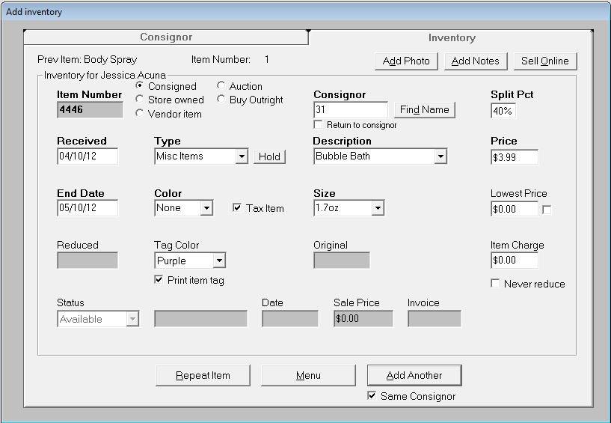

When adding a new inventory item, the inventory screen appears blank but prompts you with the next available item number. Item numbers can be manually changed but must contain only numbers and must be unique. (i.e. there cannot be two items numbered “1” on the database.)
Note: We strongly recommend that you allow ConsignPro to number your inventory for you. Simply put, there is no reason not to. ConsignPro automatically tracks who owns each item and how many items a consignor owns. Several reports can be printed showing the item listing for a consignor.
After verifying the correct item number, select whether this is a consigned, store owned, or vendor item. More information on this selection can be found in the next section of this guide under “Entering special inventory items, Vendor and Store”.
Next tab to the “Consignor Number” field and enter in the consignor number for the item you are adding. You can also use the “Find Name” button to lookup a consignor number by name.
Next, click-on or type in the remainder of required fields (those with bold tags), and click on the “Add Another”, “Menu”, or the “Repeat Item” button. These buttons are described next.

Add Inventory Buttons

Add Another - This button will save the current item and reset the inventory fields. If the “Same Consignor” checkbox is checked, the consignor number, return to consignor checkbox, and split percentages are left intact on the screen.

Menu - Used to return to the ConsignPro main menu. ConsignPro will automatically save the new record if all of the bold fields are complete.

Repeat Item - Saves the current record and repeats all of the information for the current item with a new item number. An item can be repeated as many times as necessary. After pressing the Repeat button six times, a special box will appear and allow you to enter the total number of items you are adding.
Note: Inventory tags or labels are normally not printed from this screen. They are printed from the Reports screen. More information on printing tags or labels can be found in Reports.
Note: The contents of the inventory “lists” can be changed on the “Store” screen under List Maintenance. Lists can also be made optional. More information on List Maintenance can be found in the List Maintenance section of this guide.
Note: The “Same Consignor” checkbox can be checked if you are adding several items for the same consignor. This box will allow you not to re-enter the consignor number, “Return to Consignor” checkbox, split percentage, or tag color boxes.
Hint: If you add a new consignor you can add items right from the “Add Consignor” screen by clicking the “Add Items” button in the lower right corner of the screen.

Entering inventory items, Consigned, Store, Vendor, Auction, & Buy-Outright

There are several ways to classify inventory in ConsignPro and each way has its own unique ways of being handled by the system. Each classification (consigned, store, vendor, auction, and buy-outright) is described next.
Store Owned Item: An item owned outright by the store. The owner enters the actual cost of the item (into the Store Cost field) and Price. ConsignPro uses both sale price and item cost in the accounting and reporting. The split percentage for store owned items should be set to zero. Before entering a store owned item, add the store as a consignor and put the word “Store” in the comments field on the consignor screen.
Vendor Item: An item which you’d like to enter into stock once, but sell many of. An example might be “Snickers candy bars” or “Duracell batteries”. Using vendor items prevents you from having to log in each candy bar or battery so that it can be sold.
Instead, a “Count” field allows you to enter in the quantity of vendor items you are adding. This field is required. ConsignPro will automatically decrease this count by one each time a vendor item is sold.
Note: You can specify the cost of a Vendor item in two ways. Either enter in a split percentage that represents the cost of the item as a fraction of the price of the item, OR, check the box next to Lowest Price. The box will change to “Wholesale$” and you can enter in the cost as a dollar amount.
Note: If your vendor item has a barcode already on it from the manufacturer, you can tell ConsignPro to use that barcode by going to our CustomizeCP screen and checking the “Prompt for UPC barcode on vendor items” check box. Then, when you add a vendor item, the system will prompt you to scan the existing barcode and assign that to the item. You ca then use that barcode on the Make Sale screen. This can only be accessed thru the ADD screen, not the Find screen.
Auction Item: Use this type of item if you plan to sell the item on the Internet. The system will give you a box at the bottom of the screen “Auction ID” where you can enter in the auction number – if you have one. ConsignPro does not currently interact with any auction websites but we may in a future release. You can lookup or sell an item using either the auction id or the item number.
To log a Store Owned, Auction, Vendor, or Buy-Outright item:
- Click on the appropriate “radio button” next to Item Number.
- Notice that the status correctly indicates that the item is a store, auction, or vendor item. Buy–outright items will remain as an “Available” status.
- Enter in a valid consignor number.
Important: For Store items, the contents of the consignors “comments” field for this consignor must be “Store”. You should establish a consignor record for the store and a consignor record for each vendor before adding store or vendor inventory items. ConsignPro will prompt you if this is incorrect.
- Enter in the remaining required (bold) fields and then click either “Add Another”, “Menu”, or “Repeat Item”.
- For vendor items, enter in the “Count” of items that you are adding.

Note: When entering in a “Store” item, the “Lowest Price” field automatically changes to “Store Cost”. Enter the cost of the item in this field.

Buy-Outright Item: Use this radio button to record the purchase of an item from a customer. When you make this selection, the system will:
- Automatically calculate the purchase price based on the selling “Price” that you enter. The profit margin is set by you on the CustomizeCP screen, under Store Settings. Conversely, if you enter in the price you want to pay for the item (into the Store Cost box), the system will calculate the selling price.
- Automatically deposit the money into the consignor (customers) account. You can then either keep the money on the account so that it can be used against future purchase (as in a “trade” situation), or, on Find Consignor, payout the balance as cash/check to the customer.
To turn buy-outright on, go to the CustomizeCP screen, Store Settings tab, and check “Allow buy-outright” and set the margin you’d like to make on items that you buy outright.
To print a listing of those items you just bought from a customer, return to the Find Consignor screen, lookup the consignor, and click the “Received Report” button. The system will print a listing (with prices) of items you just purchased.
To pay the consignor for these items, use the “Payout Balance” button on the Find Consignor screen. You can pay as either cash or check.

Selling or “Posting” Items

Use the “Sales Entry” screen to sell items through ConsignPro. You can reach the “Sales Entry” screen by clicking “Make Sale” from the Main Menu.
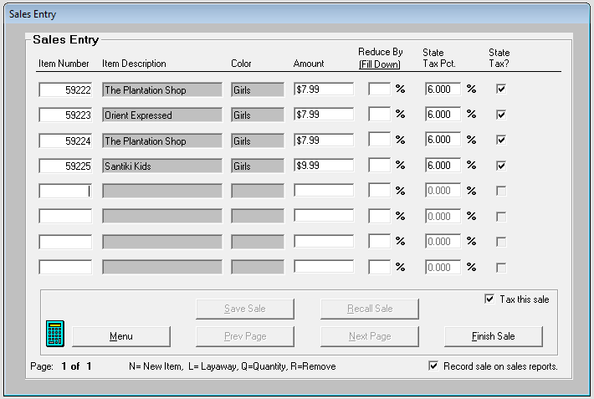

Above you will notice a sample make sale or sales entry screen. Each row represents a single sale item. Each screen holds eight items. Previous and Next Page buttons allow you to enter up to 80 items per sale.

Selling items using ConsignPro

- Enter the item number in the “Item Number” field and press the “tab” or “enter” key. The item is returned from the ConsignPro database and displayed on the sales line. Or,
- Using a scanning device, scan the barcode while the blinking cursor is on in the “Item Number” field. The item description and price will appear, and the cursor will automatically position itself at the next field so the next item number can be scanned.
- For layaway items, a special message box will appear for the salesperson to confirm that the item is being sold to the correct customer. The deposit amount accepted for the layaway item will then appear in the “Discount” box on the “Amount Due” screen discussed in Part “B” (below).
- Use the “Prev Page” and “Next Page” buttons for entering in more than 8 items. These buttons become available after entering your sixth item.
- When done entering items, click on the “Finish Sale” button. The “Amount Due” screen appears and is discussed in Part “O”.

Note: You can enter up to 80 items per sale (10 pages). After 80, you must finish the sale and begin a new one.

Note: If you wish to sell several “vendor” items at one time, put the letter “Q” into the item number box and press Tab. The system will prompt you for the vendor item number and the quantity you’d like to sell. It will then calculate out the price correctly.

Note: To save a sale so that you can complete it at a later time, click the “Save Sale” button. The system will prompt you for a name for the sale so that you can recall it at a later time. To recall a saved sale, click the “Recall Sale” button. This button is only available when saved sale files exist on your computer.

Note: To remove an item from a sale, simply type an “R” over the item number to “R”emove it. The line will remain on the screen but the item will not be sold!

Selling items not on the database

All items that you sell may not have been entered into inventory on the ConsignPro database yet. If this is the case, do the following:

- On the CustomizeCP screen, under Store Settings, check the “Sell items not on database:” checkbox. You only need to do this once.
- Enter “n” into the “Item Number” field. ConsignPro will automatically determine the next available item number.
- Press “Tab” or “Enter”.
- ConsignPro brings up a window asking you for a consignor id number or last name. You can either enter the number or begin typing in the last name and a list of consignors will appear. Select the correct person who owns the item.
- You can optionally enter a Description of the item being sold. Then click Find.
- ConsignPro will return you to the Sales Entry screen with the cursor in the Amount field. You can enter the amount of the item and then continue with the sale.

Note: If you require a more detailed description of the item you can go to the Maintain Store, CustomizeCP screen, Store Settings tab. Remove the check from “Sell items not on database”. This same process will then link you thru the Add Inventory screen where you can collect more data on the item being sold – this way is much slower that the above but does capture more information.

Reduce By: The “Reduce By” field is used to mark down any particular item by a specified percentage (ex. 10%). To remove the discount simply change the percentage to 0 (zero) and tab off of the field. Price will return to the original price. Reducing the price of an item (or items) on the Make Sale screen will reduce the amount paid to the consignor as well as the amount the store received (the discount is shared equally).

Note: Discounts taken on the Make sale screen are shared between the consignor and the store. Discounts taken on the Amount Due screen (Discount box), are only “felt” by the store. There are good reasons a store owner may wish to discount on either screen, or on both screen.

Note: If the entire sale is to be reduced by a percentage, you may the “Discount” field on the “Amount Due” screen in the Make Sale section in this guide. In this case, the store bears the entire amount of the discount. To share discounting with the consignor, do the discounting on the Make Sale screen instead.

Note: If the price of any item is reduced below the “Lowest Price” entered on the Add Inventory screen, the price appears in red and a warning message appears. ConsignPro does, however, allow the item to be sold at the reduced price.

State Tax Pct: This field is used to set the tax rate for the item and is automatically defaulted to the rate set on the Maintain Store screen. This new field was necessary because some states require certain items to be taxed at different rates than other items.

State Tax?: ConsignPro will tax individual items if the item price is greater than the “Tax Items Over” amount on the Store screen. More information on the “Tax Items Over” field is presented in “Maintain Store’ section of this guide. You can un-check any of the “Tax” check boxes at anytime, or tax items which ConsignPro doesn’t.

Tax this Sale?: This checkbox is checked by default. This box is also checked if any item on the screen is subject to state tax. If the check is removed, the entire sale is untaxed.
Calculator icon – The calculator button on the lower left corner of the screen will activate your Windows calculator. You can use the calculator to manually calculate an adjustment to a consignors account balance before you type in the new amount. For this button to work, the “calc.exe” file must be in your \Windows folder – which it usually is.
Record sale on sales reports – This check box can be used, only by the store owner, to not record the sale on any reports. This could be useful if you are selling an item to yourself or an employee. The consignor will still get paid their amount but the sale will not appear anywhere else. Consult your local taxing authority on tax laws governing your state before using this feature.

Using the Layaway Feature

Layaways with the ConsignPro system are simple if you read the following section.

Putting an item on layaway.

To put an item on layaway for a customer, do the following:

- Click “Make Sale” and type an “L” followed by the item number you’re putting on layaway (ex. L1234) in the item number box. Press “tab” or “enter” and ConsignPro will then prompt you to enter the Customers name and phone number. Press OK after you enter the name.
- Note that ConsignPro automatically calculates the amount of deposit required by using the items “Price” and the “Layaway Pct.” on the Store screen. You can always change this deposit amount!
- When you click the “Finish Sale” button, ConsignPro will allow to you accept a “group deposit” for all the items that are on layaway. For example, if the total deposits for layaway items calculate to $8.50 and the customer wants to put down a $10 deposit, this becomes the “group deposit” amount you would accept. ConsignPro will automatically divide that amount among the items being put on layaway. If you are satisfied with deposits that ConsignPro has calculated on the Make Sale screen, click “No” to the Group Deposit question. If not, click Yes and enter in the total dollar amount.
- If you lookup the item using Find Inventory, you’ll notice that its status has changed to “Layaway” and the correct customer name and deposit information is shown. This amount can be easily changed by returning to the Main Menu and using the “Tools / Layaways” function on the top of the Main Menu. Layaway maintenance functions are described in full in the beginning of this guide under “Layaways”.

Note: To put an item on layaway the item must be an “Available”, “Store” owned, or “Vendor” item.

Adding money to an existing layaway item.

After an item is in layaway status, you can remove the deposit, change the deposit, or accept additional deposits by using the Layaways function found under Tools on the top of the Main Menu. This function is described fully in the beginning of this guide under “Layaways”.

Selling an Item on layaway

Once an item in on layaway, it can be sold like any other item. To sell an item on layaway and collect the remainder due, simply use the “Make Sale” screen. Sell the item by using the item number, as you would any other item. ConsignPro will correctly credit the deposits already received on the “Amount Due” screen next to “Credits / Deposits”.

Note: Consignor balances are not updated until the item is finally sold. No layaway deposit amounts are ever applied to consignor accounts.

Note: ConsignPro does not tax layaway deposits. The item is fully taxed only when it is finally sold.

Amount Due Screen

The Amount Due screen is displayed with sale total information when you click on the “Finish Sale” button on the “Sales Entry” screen.
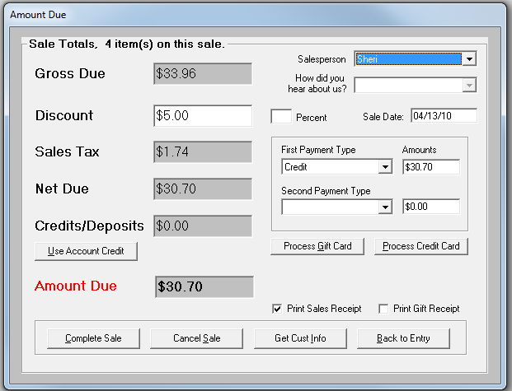
Above you will notice the “Amount Due” screen. We will now review the fields on this screen and how they are used.

Amount Due Fields

Salesperson: This box can be used to set the salesperson who is receiving credit for the sale if salespeople are being paid by commission. This field is optional. Sales names can be added to the list by adding employees using the Employees button on the Main Menu. A “Sales by Salesperson” report on the Reports page can provide you with sales totals sorted by salesperson. You can make this entry required using a checkbox on the CustomizeCP screen.

How did you hear about us? This list is set on the Maintain Lists screen and can be used to track how customers heard about your shop using the entries you put into the list. You can then run an “Advertising Report” on the Other Reports tab within the Reports screen to see where your best use of advertising money is. You can make this entry required using a checkbox on the CustomizeCP screen.

Sale Date: The date the sale is being made. This field defaults to current date but can be changed if you are posting a sale from a previous date.
Gross Due: The gross amount of all items included in the sale. Discounts applied on the “Make Sale” screen are represented in this total. You cannot key to this field.
Discount: The discount field is any discount applied to the entire sale. This field can either be keyed directly to (ex. $5.00) or calculated as a percentage of the sale by using the Percent box to the right.
Note: Discounts taken on the “Amount Due” screen are not shared with the consignor and the consignor is paid their full split percent. If you need to share a discount with the consignor, take the discount on the Make Sale screen (“Reduce by” box) rather than on this screen.
Sales Tax: The amount of sales tax calculated for this sale. For additional information on how ConsignPro calculates sales tax please refer to the “Store” section of this guide. You cannot key to this field.
Net Due: The net amount due. Gross less discounts and sales taxes.
Account Credit: Customers may also be consignors at your store with account balances. The account credit field allows consignors to use all or a portion of their account balance to pay for a purchase. To use an account credit, click on the “Use Account Credit” button. You will see the following screen appear:
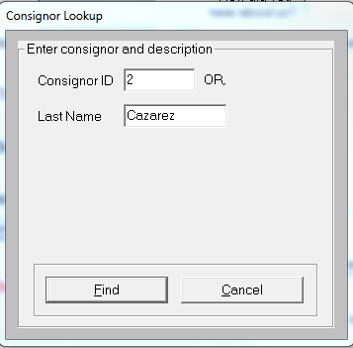
You can now enter in either the consignor’s ID or last name and click “Find”. ConsignPro will then prompt you with the following screen (if the consignor is found on the database!):
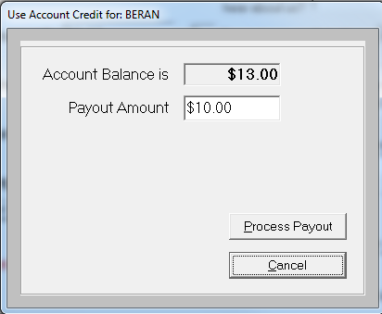
ConsignPro will allow you to either use the entire balance (default) or allow you to key in any portion of that balance. After deciding the correct amount, click Process Payout. ConsignPro returns the amount to the “Credit / Deposit” field automatically and reduces the “Amount Due” field accordingly.
Note: If a consignor account has a zero balance or one not sufficient to cover the sale amount, you can use a larger amount. When the sale is completed, the consignor’s account balance will appear as a negative amount.
Amount Due: The amount that the customer owes you for this purchase.

Payment Types: A drop-down list of the payments that your store accepts. You select what appears in this list in “List Maintenance” on the “Store” screen. More information on list maintenance can be found in the List Maintenance section of this guide.
Note: If “Cash” is selected, two new boxes appear on the screen allowing you to enter in the amount of cash received (in the Paid box). Pressing Tab, ConsignPro then calculates the amount due back to the customer (in the Due box). This is completely optional and this information is not stored in ConsignPro – it simply helps you make change.
Note: As you see, ConsignPro can allow two different payment types for a single sale if the customer wishes to split the payment between, say, cash and check. If so, you can select the second payment type and the dollar amount, after you press tab, ConsignPro automatically recalculates the other Amount for you.
Print Sales Receipt: This checkbox is checked by default and causes a receipt to be printed to the printer connected to your system. If no printer is connected, this box is unchecked and protected.
Print Gift Receipt: This will print a receipt without prices, in addition to the sales receipt.

Amount Due Buttons

Complete Sale: This button finalizes the sale, updates the database, prints a receipt, and returns you to the ConsignPro Main Menu. If you used the Paid / Change boxes, the change due is also displayed in the lower right corner of the Menu until you begin your next transaction.
Cancel Sale: Cancels the current sale and returns you to the Main Menu.
Get Cust Info: Presents a screen used to collect customer information (name, address, zip code, etc) This information can be used to print customer mailing labels or a Customer Report from the “Reports” screen. An example of this screen follows:
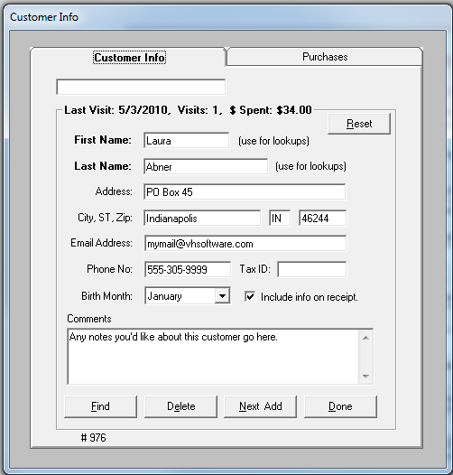
After keying in name and address information, click on the “Done” button to add the customer to the mailing database and continue with the sale. If you know the customer is already on the database, you can enter in the first OR last name and click Find to look them up. E-mail address, Phone No, Tax ID, Birth Month and Comments are optional fields.
You’ll note that at the top of the screen you have information about how many times the customer has shopped with you and how much they have spent.
If you check the “Include info on receipts” the customer’s name and address will appear on your 3” printed receipt. If you are not using a 3” receipt, this option is not available.
A second tab at the top of this screen can be used to look at the customers purchase history with your shop.
This screen is used in conjunction with the Customer Rewards screen to track customer purchase and reward them with a preset discount when they hit a certain purchase level or visit count. You can setup Customer Rewards under Maintain Store, Store Terms. That screen is described in the Maintain Store section of this guide.
If you are using customer loyalty cards, you can type in, scan in, or swipe in the card number into the box at the top of the screen. If the customer is a new one, the card number will be assigned to the customer. If the customer already has a card, you can enter the card number in the box and click Find to bring the customer up quickly.
If you’d like to require this screen on every sale, there is a checkbox to “Require customer info on sales” on the CustomizeCP screen, Store Settings tab.

Note: If you try to enter the same customer more than once, ConsignPro will warn you when you tab off of the Name field. This will prevent duplicate mailing labels from being produced.
Hint: You can also access the customer entry screen from “File / New / Customer” on the Main Menu. This allows you to add customer information without going through the “Make Sale” process. Sale data is not tracked using this method.
Hint: To lookup an existing customer quickly, enter only the first OR last name and click the “Find” button. The system will return a list of only those customers with that last name and allow you to select the customer you would like.

Back to Entry: Returns you to the “Sales Entry” screen. Returning to this screen will zero out any discount applied to the “Discount” field and reset your payment type(s). These fields should be entered again upon returning to this screen.
Process Credit Card: Clicking this button will bring up a special screen which allows you to either enter (or swipe) a credit card using ConsignPro. More information is shown next.
Process Gift Card: This button is used to both sell and redeem gift cards or gift certificates.
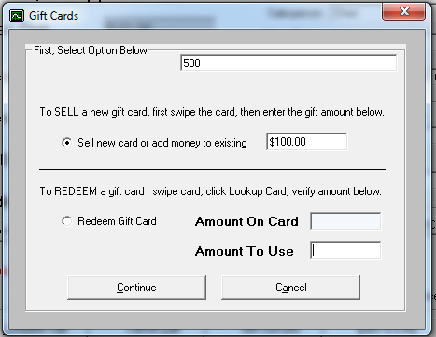

To sell or redeem a gift card/cert, begin by swiping, scanning, or typing in the card number into the box at the top of the window. Then select the action you’d like (Sell or Redeem), and lastly enter in the amount to sell it for or the amount to redeem. When finished, click Continue and they amount will transfer back to the Amount Due screen.

ConsignPro and X-Charge credit card software

ConsignPro (when combined with X-ChargeTM software) can use your high-speed Internet connection to easily process credit card transactions directly from ConsignPro. No longer do you need a credit card terminal or special credit card receipt printer. Also, since we’ve negotiated a ConsignPro group discount with Accelerate Payment Solutions, ConsignPro users receive great merchant rates for swiped credit card transactions!

To get started with credit card processing with ConsignPro, call X-Charge for a FREE rate comparison at 888-413-9545. Identify yourself as a Visual Horizons Software customer for our special group rate.

The screen below shows the credit card processing screen used by ConsignPro. This screen is described next in detail.

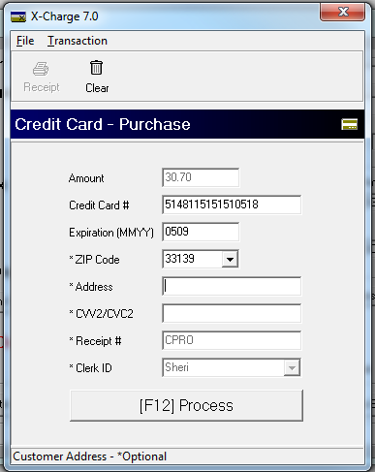

In the above example we used the MagTek credit card swipe reader (sold by us) to swipe a MasterCard. Credit card information should automatically appear on the screen.

Once the credit card number is complete (either swiped or keyed manually), click the “(F12) Process” button to begin the authorization process. At this point, ConsignPro will submit the transaction to X-Charge software (must be installed and configured properly -–see below), the transaction will be attempted using your Internet connection and ConsignPro will return an Approved or Declined message.

When you complete the sale, ConsignPro will print both a sales receipt and a credit card receipt (for the customer to sign) using your Star receipt printer. Note that a special Star 3” receipt printer is required to use credit card processing from within ConsignPro.

System Requirements:

- ConsignPro Version 8.0 (or later).
- X-Charge software by Accelerated Payment Solutions.
- A high speed Internet connection (DSL / Cable)
- A credit-card swipe reader (optional, but suggested).
- A Star TSP600 receipt printer.
- A signed merchant agreement with CAM Commerce Solutions.

How to get started:

- Contact Accelerated Payment Solutions at 888-413-9545. They will ask you to provide your last merchant card processing statement to determine the best rates they can provide. Identify yourself as a Visual Horizons Software customer to be included with our group rates.
- After reviewing and accepting their offer, sign a merchant agreement with Accelerated Payment Solutions.
- Install Version 8.0 (or later) of ConsignPro.
- Call X-Charge support to configure X-Charge at 800.338.6614
- Go to the Maintain Store, CustomizeCP screen. Click the Store Settings tab at the top. Put a check mark in the “Use X-Charge credit card system” check box.

Note: More information about ConsignPro and X-Charge can be found at www.consignpro.com/ccard.php

Looking up an Invoice - Void Processing

The “Invoice Lookup” screen is used to lookup or re-print sales invoices (receipts) for anything that was sold using ConsignPro. This screen is also used for customer returns (i.e. to void either an entire sale or individual items from a sale).
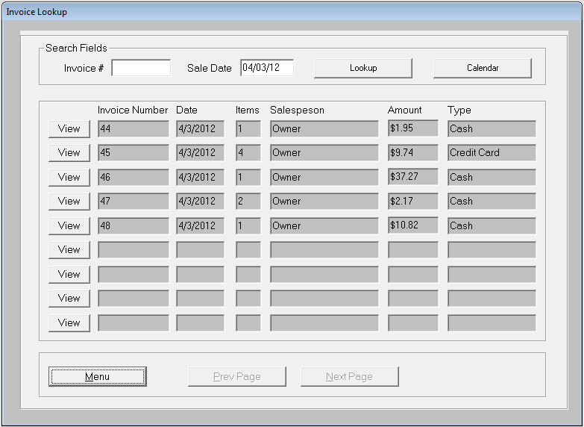
Above is a sample of the “Lookup Invoice” screen. In this example we used the Calendar button to lookup all invoices for 4/3/2102.

Looking up an Invoice

To lookup an invoice you can either enter in the invoice number, if known, or the date the invoice was originally produced (ex. sale date). A handy calendar button is used to quickly access and select a date off of a calendar.
After you’ve found the invoice that you wish to review, click on the “View” button to the left of the invoice entry. If an invoice date returns several invoices (which it probably will), you can use the “Prev Page” and “Next Page” buttons to review the amount of sale and salesperson to further refine your selection.
After finding the correct invoice and clicking on “View”, the following screen appears:
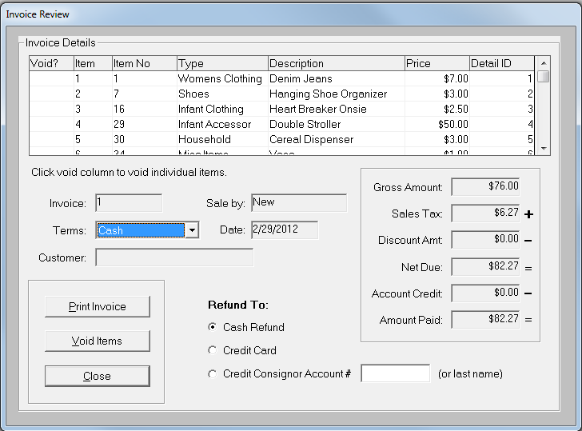
This screen shows the invoice in more detail. You will notice a breakdown of all the items that are part of the invoice as well as a breakdown of the Amount Paid for the sale. If more than four items are on the invoice, an elevator bar allows you to scroll through the item list in the invoice details grid.

Voiding an entire sale
If you are voiding the entire sale, simply click on the “Void Items” button. ConsignPro will prompt you and ask if you’d like to continue with the void. Selecting “Yes” will return the items to “Available” status and debit the consignor account balances of the affected consignor accounts.

Voiding individual items
If you are voiding an individual item, simply click in the “Void?” column box in the details grid next to the item that you wish to void. The box will change to “Yes”. You can select as few or as many items (rows) as you’d like.
Clicking “Void Items” will remove the selected item(s) from the invoice and return it to inventory as “Available” and debit the consignor account that the item(s) were sold from.
Terms: If the payment terms were incorrect during the posting process, you can change them here and they will be saved when you close this screen.
Customer: The customer who purchased the items.
Credit Consignor Account #: If the customer making the return is also a consignor on the system, ConsignPro can automatically credit that consignor’s account with the money from the return. To use this feature use the “Credit Consignor Account # box”. You can either type in the consignor number or start typing in their last name to select the consignor from a list. Do this before using the “Void Items” button. No cash should be returned to the customer when using this option or the customer would be paid twice!
Print Invoice: This button simply reprints the customer invoice and returns to the invoice lookup screen. This button is disabled if a printer is not connected to your computer.
Close: Returns you to the invoice lookup screen.

Lookup or Adding Employees

The Employees screen is used to maintain employee information including password and employee permissions.

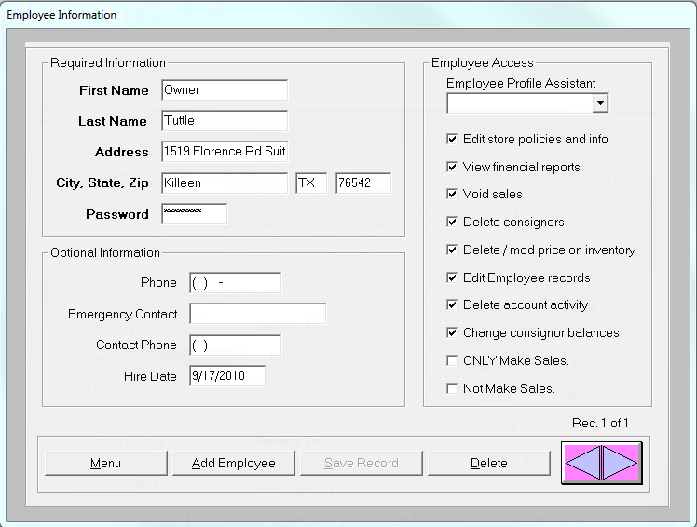

The above is a sample of the Employees screen. You will notice basic employee information and other fields and buttons. Some of these fields are explained further the rest are self-explanatory. The bold fields are required, the rest are not.
First Name: The employee first name which also appears in the drop-down list during the sign on/sign off process.
Password: The password that this employee uses to sign onto ConsignPro. The password must be between five and eight characters.

Employee Profile Assistant
You can assign an employee profile for each employee you add to the system. The employee profile helps determines which screens and/or functions that an employee can perform in the ConsignPro program. Setting these features carefully limits the “destructive” ability of any employee using the system. Each option is described next:
Edit store policies and info: This allows the employee to go into the Maintain Store screen and change information. Typically only the store owner or manager has this option checked. At least one employee MUST have this option turned on!
View financial reports: This option allows the employee to look at sensitive financial reports on the Reports page. These reports show sales and income information that store owners may not wish to share with employees.
Void sales: This allows the employee to void entire or partial sales through Lookup Invoice.
Delete consignors: Allows the employee to delete consignors from the system.
Delete / mod prices on inventory: Allows the employee to delete consigned or store owned inventory as well as change the prices and split percentages on items.
Edit employee records: Allows the employee to add or change information on the Employee screen.
Delete account activity: Allows the employee to remove account activity records on the Account Activity window in the Find Consignor screen.
Change consignor balances: Allows the employee to make manual changes to a consignors account balance and split percentage on the Find Consignor screen.
ONLY Make Sales: This employee will only have access to the Make Sale screen when they log into the system.
Not Make Sales: This employee will not have any access to the Make Sale screen.
The Employee Profile Assistant allows you to set the above check boxes automatically based on the “title” of employee you are adding to the system. This can be refined as necessary using individual checkboxes but serves as a guide for new store owners.
Menu: Returns to the ConsignPro Main Menu. If changes have been made, ConsignPro prompts you to save them with a Yes/No message box.
Add Employee: When you want to add a new employee to the system, click this button FIRST. That will clear the screen. Then enter the employee information and click the Save button or return to the Main Menu (data will be saved automatically). All of the “bold” fields must be completed to add a new employee.
Save Record: After entering all of the bold fields, this button is enabled. Clicking this button saves the new employee to the database.
Delete: This button is used to delete the current employee from the database. You should never delete all employees from the database. The lower right corner shows you how many employees are in the system (ex. Rec. 2 of 3)
Previous / Next arrows: These arrows are used to “scroll” through the employees on the database. You can lookup or change any employee record on the ConsignPro database using these arrows.

ConsignPro Reporting
ConsignPro has several pre-defined reports that allow you to examine store inventory, sales, store profits, and print labels or tags.
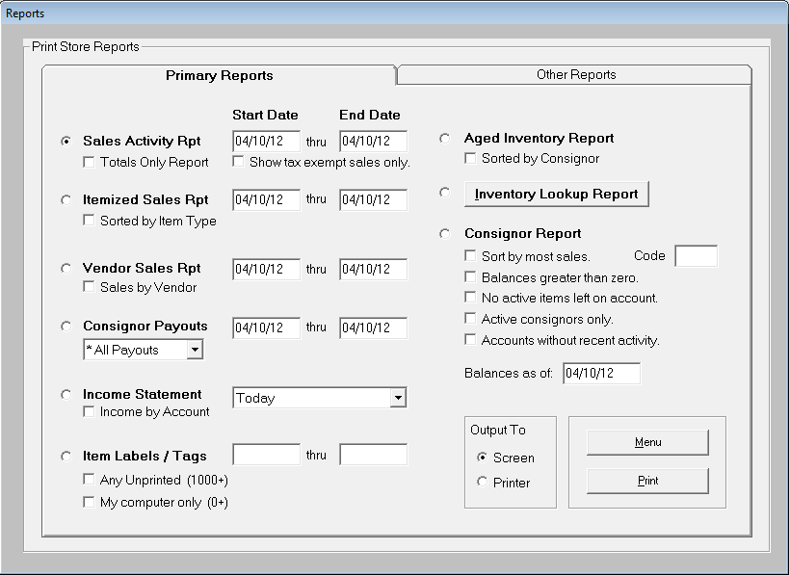
Above is a sample Reports screen. Each of the ConsignPro reports will be discussed next. Reports can either be printed to the screen or to any attached full-page printer. To select the report you would like to use, click on the “radio button” to the left of the report name.
Important: You can only access “Reports” if you have a printer connected to your computer.

Primary Reports

Sales Activity Report

This report summarizes sales activity for any period of time using the “Start Date” and “End Dates” that are keyed. Sales information shows invoice numbers, Gross Due, Layaway Deposits, Discounts, Sales Tax, Store Credits, and Received amounts. This report is automatically produced at the end of each day and shows store revenues for the day.
If you check off “Totals Only Report”, the report that is produced will have only sales totals on it -- not detailed information about specific invoices. The “Sale Totals Report” is also broken down by payment type if that information is needed.

If you check off “Show tax exempt sales only”, the system will produce a report of those sales that were not taxed. You should subtract the total from this report from the Sales Activity Report total to get your total taxable sales for state tax reporting.

Note: All dates in ConsignPro can be entered without the slashes. For example, if you key in 080199 (must be six digits), ConsignPro will automatically insert slashes for you when you press tab to leave the date field.

Itemized Sales Report

This report shows a breakdown of individual items sold for any dates you enter. Shown on this report are: consignor names and numbers, item numbers, item descriptions, invoice numbers, and sale prices. This report can be printed at any time from either the Reports screen, or at the end of the day by checking the “Print Itemized Sales Report” check box on the “Shutdown Options” screen.

Using the “Sorted by Item Type” checkbox, this report is sorted and totaled by Item Types and Descriptions -- telling you what the best selling items are in your store. On this report are Original Price, Sale Price, Markdowns, Percent of total sales, Item Count, and Average selling price. Store owners can use this report to find their best selling items and determine average prices. This report is also limited by start and end dates.

To create an even smaller report you can click the “Category totals only” after clicking “Sorted by Item Type”. This will give you a department breakdown on (usually) a single page.

Vendor Sales Report:

This report is similar to the “Itemized Sales Report” but shows you summarized sales of items that were added at “Vendor” items to the system. This report was necessary because vendor items do not show up on the “Itemized Sales Report”.

This report is sorted and grouped by vendor account and vendor items are summarized with a count of each vendor item number sold. Totals per item and grand totals are also included on this report. Using the “Sales by Vendor” option allows you to enter the vendor account number to report only on that particular vendor account.

Consignor Payouts

This powerful report will show you all of the consignor payouts you’ve made using the system for any period of time. To find all cash and check payouts made by ConsignPro in 2011, simply type 1/1/2011 and 12/31/2011 into the Start and End Date boxes respectively, then press Print.

You can select the type of payouts that are shown on the report using the drop-list. The default is “All Payouts”.

Income Statement

The income statement will produce a report that describes both revenue and expense activity over a period of time. This report can be produced for any particular period of time (ex. Year-to-Date, 1st Quarter, Jan-Jun, etc.). You can also use the “Pick my own dates” list entry to enter in your own starting and ending dates. Using the “Income by Account” checkbox will only account for items belonging to a particular consignor account.

Item Labels / Tags

This option prints inventory labels or tags including bar codes or markdown information. Labels can be printed for either a range of item numbers (ex. 101 thru 200) or “Any Unprinted”. The “Any Unprinted” option will print inventory labels for those items on the database which have not yet been printed. Labels are designed to be printed on a variety of tag and label sizes and styles. More information on labels and tags sizes and styles can be found in online at www.consignpro.com/tags.php

Note: Using the “My computer only” checkbox will only print tags for inventory items added on a particular computer. This option is useful for networked ConsignPro users who enter inventory on multiple computers yet want the tickets to print separately.

Note: ConsignPro can also print small 1” by 1” thermal labels or butterfly style jewelry tags. These are both available from Forms Plus at 800.241.2319 and you MUST be using a Zebra thermal tag printer to use either of these. If you have them setup correctly (see the Connections part of this guide) you will see two additional checkboxes on this screen. Select either box when printing that type of label and be sure to change the roll in your printer as well!

Layaway Report

This report shows all customers who have items on layaway, their names, deposit amounts, amount remaining, and the date the item was placed on layaway. The report is sorted by layaway group so you can easily see what items belong to each layaway and the deposits given on each. You can also produce this report for a particular customer by entering their name when prompted as it was entered during the initial layaway.
Aged Inventory Report

This report shows the items in that are past their “End Date” on the “Find Inventory” screen. Items on this report can be retrieved from the store and either returned to the consignor or donated. ConsignPro allows you to enter a “Received Date”. Items will only appear on the Aged Inventory report where the “Received Date” for the item is greater than this date. This can be used to show only newly expired items.

You can sort and group the report by consignor id if you check the “Sorted by Consignor” checkbox.

Inventory Lookup Report

Clicking the “Inventory Lookup Report” button will display the following criteria selection screen. This screen is used to set the criteria you’d like to use when selecting items to appear on the “Inventory Lookup Report”.

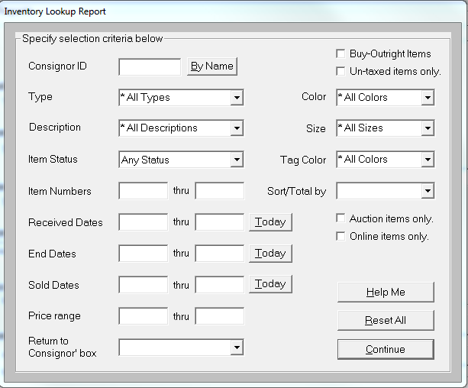
This powerful report will print a listing of inventory on your database using a combination of lookup choices such as: consignor number, type, description, size/color, item numbers, received dates, end dates, sold dates, tag colors, price ranges or statuses.
For example, you may wish to view all of the Desks that are “Available” on the database or all of the “Sold” items for consignor number 3212. Combinations of any of these options allow you to find almost any type of inventory item on your database. If none are selected, ConsignPro prints a listing of all items on the database.
You can also sort and total the report using the “Sort/Total by:” box. This might be useful if you’d like to see totals for a particular Type or Description of items to see what is selling the best within your store.
When you have finished setting your criteria, simply click “Continue” to return to the “Reports” page and click “Print” to produce the “Inventory Report”.
Note: You can easily use the Inventory Report to search for lost-tag items. To do so, simply type into the “Type” and/or “Description” boxes some words contained in the type or description of the item.
For example, if you have a pair of Calvin Klein jeans without a tag, you can type “Calvin” in the Description box and ConsignPro will return a report will all items containing the word “Calvin” somewhere in the description! Use any portion or any word that is part of either Type or Description and ConsignPro will perform a “wildcard” search of your database.
Consignor Report
This report shows all consignors on the database and their account balance. The date the report was created is displayed as well as consignor information including consignor number, name, phone numbers and account balance. This report can either be sorted by consignor id or by last name (the system will ask you when you print it to either the screen or printer).
To see a list of your best consignors, click the “Sort by most sales” report checkbox.
To report on only those consignors who have account balances greater than zero, click the “Balances greater than zero” checkbox.
To report on only those consignors who have no active items on their accounts, check off the “No active items left on account” checkbox. This may be handy if you only pay consignors for their items when their consignment period is over. Having no active items generally means that their consignment period is over or that all items have been sold.
If you’re interested in the balances of your consignor accounts as of a previous date, you can enter that date into the “Balances as of” box.

Other Reports
Click the Other Reports Tab at the top of the Reports screen for the following reports. The following screen appears:
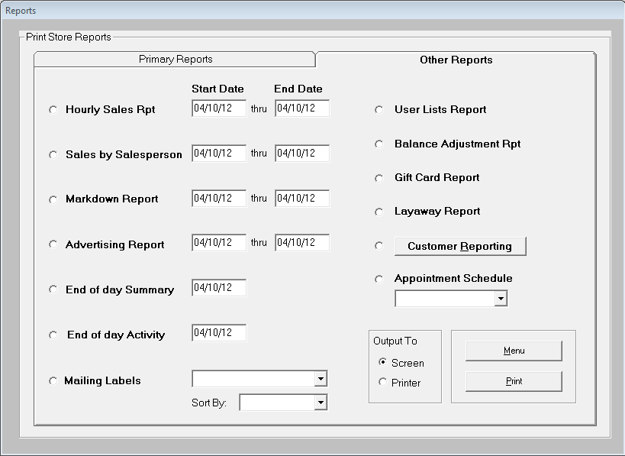
Hourly Sales Report
This report gives you an hour-by-hour breakdown of store sales. This is particularly helpful if you are trying to determine the busiest hours in your store. You can run this report from any start date through end date.
Sales by Salesperson
The Sales by Salesperson report gives a breakdown of store sales sorted and sub-totaled by salesperson. A salesperson can receive credit for a sale by selecting the salesperson name on the Amount Due screen. If you do not pay salespeople by commission, this report may not be useful to you.
Markdown Report
This report will show you all items that were marked down between the two dates that are entered. To find the items marked down in the month of February, simply type 2/1/2006 and 2/28/2006 into the Start and End Date boxes respectively, then press Print.
Advertising Report
This report shows how your customers heard about you. It works off of the “How did you hear about us” drop down list on the Amount Due screen. It will show you where your best return on your advertising spending is coming from. You can run this report for any date range you’d like.
End of Day Summary
The End of Day Summary report normally prints at the end of each day during Shutdown processing (if selected) and presents you with a summary of that day’s activity. This report can be produced for any time period. If you are using our Star 3” receipt printer, the Summary Report will automatically print to that printer. In my opinion this is one of our best reports!
Mailing Labels
This option prints mailing labels for customers, consignors, or both. Customer information is gathered during the “Make Sale” process on the Amount Due screen (Get Cust Info). Mailing labels print on Avery labels of 1” by 2 5/8” (30 per page). Consignor mailing labels can be sorted by last name, zip code, or consignor number. Customer mailing labels can be sorted by zip code or first name.
Note: You can eliminate duplicate customer labels by going to the customer lookup screen (File / New / Customer on the Main Menu) and removing customers that appear more than once.
Note: You can narrow down the customers or consignors that you send mailings to by clicking the “Set Cons Criteria” or the “Set customer selection criteria” buttons. These features are described in more detail next.

User Lists Report

This report shows all of the items that are on the user lists that can be maintained from the Store screen. Lists include Item Type, Description, Size, Color, Payment types, and Tag Colors.
Balance Adjustment Report
This report will show all the balances adjustments that were done on the Find Consignor screen. Balance adjustments are changes to a consignor’s account balance made manually by an employee. This report was created to help store owners track balance changes and possibly spot dishonest behavior by store clerks. When printed, the system will ask to only show adjustments made after a certain date to limit the activity on the report.
Customer Report
The customer report is a detailed listing of all the customers that you’ve entered into the “Amount Due” screen using the “Get Cust Info” button. The report shows: name, address, e-mail, phone, last visit date, number of visits, total dollars spent, and average sale amount. This report can be used to study the purchase habits of your best and worst customers.
Some store owners use this information to tailor mailings to frequent or infrequent customers. To further customize the information on this report click the “Set Customer Selection Criteria” button. When you do, this screen appears:
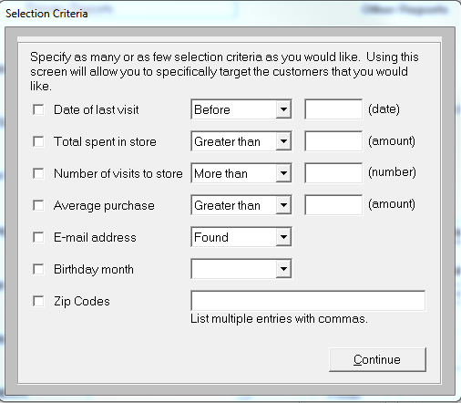
You can tailor either the customers that appear on the “Customer Report” or the customer mailing labels that you print by using this screen. You can use as many, or as few, of these options as you’d like to narrow your customer selection.
Date of last visit: Compares the date you enter to the last date the customer was accessed through the Make Sale screen.
Total spent in store: Compares the amount you enter to the total money that customer has spent in your store.
Number of visits to store: Compares the number you enter to the number of times the customer has purchased in your store.
Average Purchase: Compares the amount you enter to the average purchase amount of any customer. For example, if you enter $15.00, the system will only show customers whose average purchase exceeded $15.00.
E-mail address: You can print mailing labels for only those customers who do not have an e-mail address. This can be used to cut down on your postage expense.
Birthday month: You can use this selection to print mailing labels for birthdays in, for example, August so that you can send out birthday cards.
Zip Codes: You can list out as many zip codes as you like. Use a comma to separate multiple zip-code entries (ex. 06050, 04023, 06450)
Again, any combination of these fields can be used. The selections we’ve made above would show all customers who live in the 06067 zip code that have an average purchase greater than $50. The ways you can slice and dice customer information are almost limitless!
Note: Customer information will only be 100% complete if you always use the “Get Cust Info” button before completing a sale on the Amount Due screen. You can force this using a checkbox on the CustomizeCP screen.
Similarly to the customer criteria screen, using the “Set Cons Criteria” button will allow you to limit the mailing labels that are printed for your consignors. When clicked, the following screen appears:
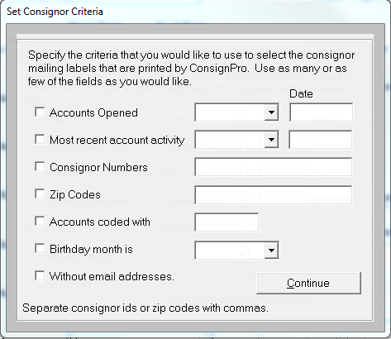
Accounts Opened – This field can be used to only print consignor mailing labels for those consignor accounts opened before or after a particular date.
Most recent account activity – This field can be used to only print consignor mailing labels for those accounts that are more or less active. Activity is based on the Activity date on the Find Consignor screen. This date is updated by the system when inventory is added to a consignors account or they are paid money from their account.
Consignor Numbers – You can list the consignor id numbers for those consignors who you would like to print mailing labels for. Separate multiple consignor id numbers with commas (ex. 1, 5, 9, 10).
Zip Codes – This allows you to only print consignor mailing labels for consignors who live in a particular zip code.
Accounts coded with – If you use the Code field in the Find / Add Consignor screen you can print mailing labels for only accounts coded a certain way.
Birthday month is – You can select a birth month to only print mailing labels for consignors born in a certain month. This can be used to mail birthday cards out.
Without e-mail addresses – Limit your consignor mailings to only those consignors who do not have e-mail addresses on file.
Note: You can use any combination of these fields to limit the number of mailing labels you receive. The more fields you use the fewer accounts which will be selected.
After you have finished setting the selection criteria, click Continue and then print. Output for mailing labels can be printed to either the screen or to the printer.

Appointment Schedule

This report will show you all appointments you’ve entered into the Scheduler tool above the Main Menu. You can run this report for Today, Tomorrow, or This Month.

Gift Card Report

This report shows all open gift cards or certificates currently in the system. Gift cards are sold or redeemed on the Amount Due screen using the “Process gift card” button.

Note: All dates in ConsignPro can be entered without the slashes. For example, if you key in 080102 (must be six digits), ConsignPro will automatically insert slashes for you when you press tab to leave the date field.

Maintain Store Information

The store screen allows you to maintain basic store information, specify tax and markdown terms, print consignor checks, customize your copy of ConsignPro, and maintain inventory lists.
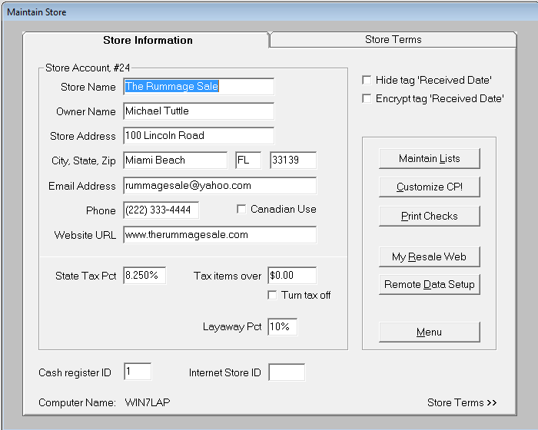
The above screen is a sample store screen. It is important to note that this screen has two “tabs”, one saying “Store Information”, the other saying “Store Terms”. You can either click on the “tabs” at the top of the screen to turn the page, or click on the wording (see the arrow) at the bottom to turn the page. Each page will be explained fully in this section!
Note: If you setup a consignor account for the store, the consignor account number will appear in the title of the window frame. In this case, consignor account #24 was setup for the store account.
We will now describe how ConsignPro uses several of the fields and buttons on this screen.

Store Information tab

This tab contains basic store information and allows you to access other screens (ex. Maintain List, Print Checks, etc). Each field will be described next.
Store Name and Address field: The store name and address appear on customer receipts and ConsignPro reports.
State Tax Pct: The applicable percentage of state tax payable in your state. This amount should be entered as a decimal (ex. 07 for 7%). ConsignPro will calculate the amount of state tax due during a sale using this percentage. If state tax is not applicable, this field should be 0.00.
Tax Items Over: This is the dollar amount at which items are subject to a state tax. For example, in Connecticut items over $50 are subject to state tax. If all items are taxable, this field should be 0.00. If no items are taxable, click the “Turn tax off” checkbox.
Note: As you add items on the Add Inventory screen, the “Taxable?” checkbox should set itself based on your selections here. You can use that checkbox to selectively tax items when they are eventually sold on the Make Sale screen.
Layaway Percentage This feature gives store owners the option of setting a default percentage for layaway deposits. For example, if this is set to 10%, ConsignPro will automatically calculate 10% of the selling price and use that as the deposit amount when using the Make Sale screen to put an item on Layaway.
Hide ‘Received Date’: Checking this box will print inventory tags or labels without the item ‘Received Date’. Some owners like this feature because it prevents customers from knowing when an item was brought into the store.
Encrypt tag ‘Received Date’: This feature will give store owners the option of encrypting the ‘Received Date’ on the inventory tags. Instead of a typical "mm/dd/yy" format, the date will appear in encrypted form so that only the store owner is aware of the date.
Cash register ID # -- If you would like to separate sales by computer (for our networked customers), you can enter in a separate register id on each computer. (ex.1 and 2). The Sales Activity Report, and other end of day reports, will give you a breakdown by Register ID.
Internet Store ID: ConsignPro has several Internet enable features that use this special box. For example, you can backup your ConsignPro database at the end of the day to our corporate server. This ensures complete protection from data loss in the event of a fire, flood, crash, theft, etc. You can also sign up for MyResaleWeb.com which allows your consignors to view their account information via the Internet. And lastly, our Remote Data Loader allows you to enter inventory via the Internet. More information is presented later in this guide. Call us if you would like to use these features, there is a fee for each.

Store Terms Tab

This tab contains information about the markdown terms, contract, and receipt wording, store split percentage, and buyers fees. These fields are usually set once and left alone unless a store changes its policies. Each field will be described next.
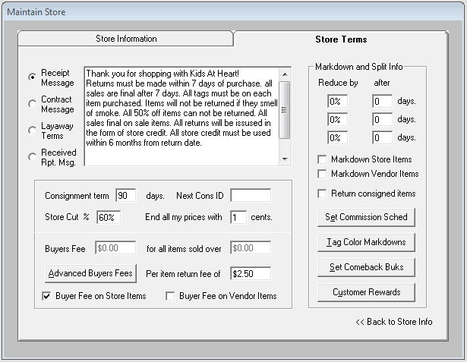
Receipt Message: This message will appear at the bottom of each sales receipt that you print during a sale. Store owners routinely print return policy information in this field.
Contract Message: The information entered into the box (when this “radio button” is clicked) will appear on consignor contracts. You can enter as many lines of information as you’d like. The “enter” key separates lines of text when contracts print. You should experiment by entering information in this box and printing a contract for any consignor to see how what you’ve entered appears on a printed contract. You can then make changes and retest them by printing another contract.
Layaway Terms: The information entered into the box (when this “radio button” is clicked) will appear on the bottom of the Layaway Report printed on the Reports page. Store owners routinely print layaway information in this field.
Received Rpt. Msg: The information entered into the box (when this “radio button” is clicked) will appear on the bottom of the “Received Report”. The received report is typically given to consignors as a receipt for the items they have dropped off with your store. The received report can be easily printed from the “Find Consignor” screen.
Markdown and Split Info: These fields are used by ConsignPro to automatically markdown inventory at the end of each day. ConsignPro will check inventory items daily to determine if markdowns are necessary. If so, ConsignPro reduces the item price by the correct percentage and then prints a new inventory label/tag with the reduced price on it (if you choose to do so).
In the sample shown, the store is using three markdown periods. After the first 30 days, the item is marked down by 25%. After an additional 30 days the item becomes marked down by 50% and after 20 more days, 75% of the original prices. Example:
# of days Item Cost
0 to 30 $100
Day 31 $75
Day 61 $50
Day 81 $25

Note: You can specify between zero and three automatic markdown periods. To specify no automatic markdowns, make all three periods zero.
Markdown Store Items: If checked, ConsignPro will markdown items logged in as store owned items. If not, ConsignPro will never markdown store items.
Markdown Vendor Items: If checked, ConsignPro will markdown items logged in as vendor owned items. If not, ConsignPro will never markdown vendor items.
Note: If all markdown terms are left at zero, ConsignPro will never markdown any items automatically.
Returned consigned items: If checked, ConsignPro will automatically check the “Wants items returned” checkbox when you add a consignor to the database. If not, the box will not be checked on the Add Consignor screen. Put a check in this box if you generally return items to consignors after the consignment period is up.
Consignment term: Use this field to set the number of days the items in your store are consigned for. When adding an inventory item, ConsignPro will add this many days to the “Received Date” to calculate the correct “End Date”. After an item expires (i.e. the “End Date” has passed), ConsignPro can automatically process the item. Specific information on how ConsignPro can treat expired items, see “Customize CP” in this guide.
Next Cons ID: This field can be used to reset the consignor ID that is used by the system during “Add Consignor” to any number other than the ConsignPro assigned one.
Store Cut %: The percentage of each sale that the store keeps. This then becomes the default percentage when adding and selling inventory items. If an inventory item is added and the “Split Pct” field is changed, that percentage becomes the split for that item only. You can also specify consignor split percentages for particular consignors when you add a new consignor to the system on the “Add Consignor” screen.
Next Cons ID: Use this field only if you would like the system to reset the starting number for the next consignor added to the system. This would only be useful if you knew there was a group of unused consignor id numbers and wanted to begin using those numbers.
End all my prices with x cents: This field can be used to tell ConsignPro to automatically put x cents on every item you add to the database. For example, if you make this field 98, ConsignPro will automatically add 98 cents to any new item that you add. It will ONLY add this “price suffix” if you key a whole dollar amount (example 10 would become 10.98 when you tab off the “Rack Price” field). If you key in “4.55” to the “Rack Price” field, ConsignPro will leave this amount alone and not add 98 cents to it because you’ve typed in the cents yourself. Some store owners like this because all the prices in their store, for example, may end with 98 cents.
Per item return fee of – If you use this field, ConsignPro can automatically charge the consignor a fee (ex.50 cents) when the item status is changed to “Returned” using either the Quick Returns feature or changing the status box to “Returned” on the Find Inventory screen. Some store owners charge this fee to consignors for the trouble of collecting, separating, and returning the item to the consignors. This will appear as fee on the consignor account activity statement.
Buyer’s fee for all items sold over x dollars:
Definition of a “buyer’s fee”
A “buyer’s fee” is a dollar amount added to the inventory tag or label price when printed. The buyer pays this premium price, but the consignor is never shown it (unless they look at the tag on their item).
Why use “buyer’s fees”?
Some store owners use buyer’s fees to offset tag prices and the cost of tagging an item. The consignor still believes they are receiving the correct split percentage when an item sells because they are typically not made aware that the buyers fee because they do not appear on any consignor reports.
How do they work with ConsignPro?
First, a “buyer’s fee” is set on this screen. When tags are printed by the system, the “buyer’s fee” is added to the “Price” you entered when adding the item. When the item is sold, the Make Sale screen reflects this new price but it is subtracted off the top before the money is split with the consignor.
An example:

You enter $1 into the “buyers fee” for all items priced over $5. You enter an item through “Add Inventory” and enter a “Rack Price” of, say, $20. The ticket that prints has a price on it of $21 (Rack Price + buyer’s fee). The item is sold and the customer pays $21. The one dollar is subtracted from the proceeds and the consignor receives $10 (assuming a 50% split). All the reports the consignor ever sees is that the item was priced at $20 and they received $10.

Note: Buyers fees can be excluded from store or vendor items by removing the checks from the Store and Vendor item check boxes.

Advanced Buyers Fees Button: When you click this button, the following screen appears:

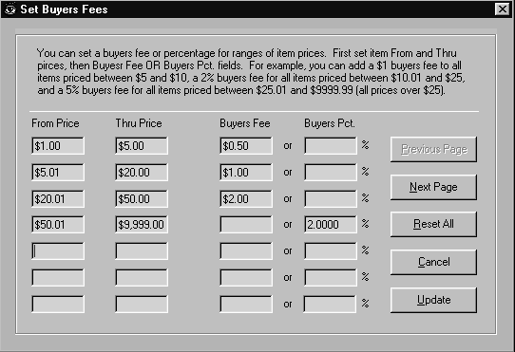
You can set buyers fees based on the price of the item and either make it a flat dollar amount or a percentage of the item’ price.

In this example we said that items priced: between $1 and $5 will have a 50 cent buyer’s fee, between $5.01 and $20 will have a $1 buyer’s fee, between $20.01 and $50 will have a $2 buyer’s fee, and for any item priced over $50, the buyer’s fee will be 2% of the Rack Price.

The Previous Page, Next Page, Reset All, Cancel, and Update buttons do exactly what they say and shouldn’t require additional explanation.

Note: To remove all buyers’ fees, click the “Reset All” button and then click “Update”.

Note: Both “Update” and “Cancel” will each return you to the Maintain Store screen.

Make buyers fees reduce with markdowns and discounts – If you use this checkbox the system will recalculate the buyer’s fee when you sell the item – if the price has been reduced. For example, if an $8 item is reduced to $4 the buyer’s fee will recalculate from $1 to $.50. using the Advanced Buyers fees in our example.

Store Buttons
Customize CP!: This button is used to bring up a special settings screen. Information on this screen controls ConsignPro printing, receipts, cash-drawer, labels, inventory and startup options. CP Settings are described in detail in Maintain Store.
Maintain Lists: This button is used to access the List Maintenance screen. This screen is used to build the lists used for inventory (ex. Type, Description, Color, Size) and payment options (ex. Cash, Visa, Check, etc.). List Maintenance is presented next.
Print Checks: This button is used to print consignor checks or reprint reports that occur during check printing. ConsignPro will automatically produce checks payable to consignors with balances greater than zero. More information on check printing is presented in the check printing section of this guide.
Menu: Returns you to the ConsignPro main menu.
Set Commission Sched: You can have the system reduce the consignor split percentage on an item based on how long it was in the store before it was sold. This is done on the following screen

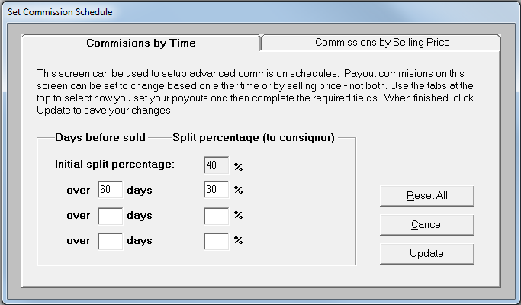
In our simple example we had the system pay the consignor 30% instead of 40% if the item is in the store longer than 60 days. Not many shops use this feature but we included it to make ConsignPro the most complete program on the market!
The “Commission by Price” tab can be used to set a consignor split based on the final selling price of the item.
Tag Color Markdown: The Tag Color Markdown button is used to assign tag colors and markdown percentages. Markdowns will automatically be taken when an item is sold using the Make Sale screen. When clicked, the following screen appears:

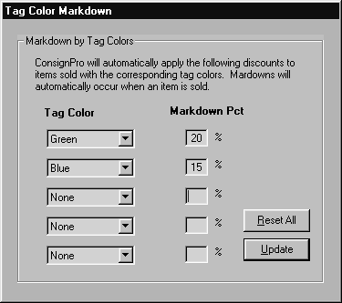
If you would like to do a “storewide sale” regardless of tag color, you can choose “* All items” in the FIRST list box and then set the sale percentage amount. This will cause ALL items to be on sale until this is reset.

Set Comeback Buks

Comeback Buks are designed as a marketing tool built into ConsignPro to encourage repeat business. When used in conjunction with one of our 3” Star receipt printers, a special coupon will print on the bottom of the customer sales receipt. The coupon will be for an amount based on the amount of their “current” purchase or a flat dollar amount. An expiration date can also be added to the coupon. To set Comeback Buks, click the button.

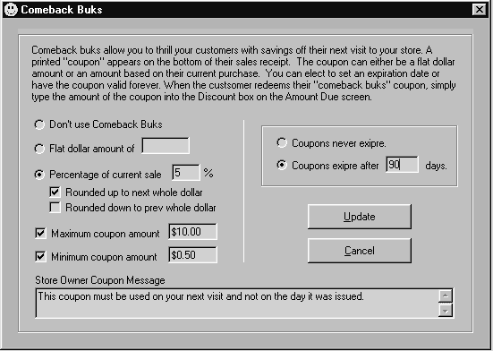
You can set the options on the Comeback Buks screen to determine the amount of the coupon that is printed when a sale is made. In our example, we chose a coupon equal to 5% of the current sale rounded up to the next dollar. We’ve elected a maximum coupon amount of $10 and a minimum amount of 50 cents. Our coupon expires after 90 days from the current sale date. A store owner message can be included on the bottom of the coupon if you have any special terms you’d like to include!

Note: The system default is not to use Comeback Buks.

Customer Rewards: This button brings up the following screen to setup a customer rewards program.

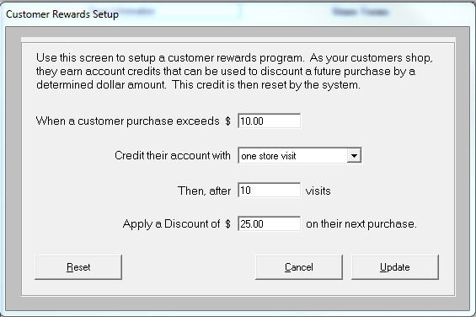

This screen is used to setup a rewards program. You can set a reward based either on the number of visits to your store or the total amount spent (regardless of the number of visits). You can then set a “reward goal” and give the customer a discount when that goal is reached. This takes the place of typical “punch cards” that you may be familiar with.

This feature only works if you reliably use the “Get Cust Info” button on our Amount Due screen – so that the purchase can be tied to a specific customer. On the CustomizeCP screen, you can ensure this happens by checking the “Require cust info on sales” checkbox.

When the reward total is reached, the system will ask if you’d like to apply the discount on that sale and reset all purchase totals. If the total discount is not used on that sale, the system will carry forward any remaining discount to be used on the next sale automatically.

MyResaleWeb.com

ConsignPro can send consignor data to the Internet so that your consignors can view their accounts online thru a website called MyResaleWeb.com. There is a charge for this service, as of this printing the charge is $14.95 / month ($99 for the first year -Special). To learn all about this new service please visit: www.consignpro.com/mrwinfo.php

To turn this service on, click the “MyResaleWeb” button on the Maintain Store screen. The following screen appears.

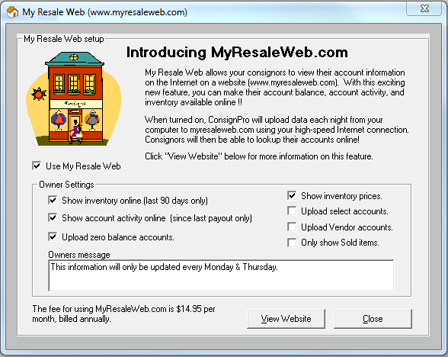

To turn this feature on, call us at 888.721.9767. We will help you configure this screen so that the system sends your data to our website at the end of each day.

ConsignPro Settings

The following screen is accessed from the “Store” screen by clicking on “Customize CP!” Each field is described in detail next.

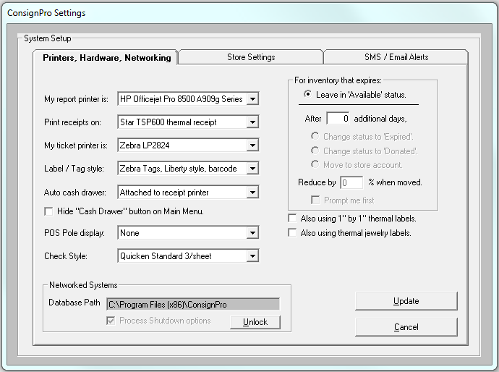

Settings Fields

My report printer is: The report printer drop down list is used to select the printer that ConsignPro should use for printing reports to. This is typically an inkjet or laser jet printer. The printer that’s chosen here should also be selected as the “default” printer in the Windows printer’s folder.
Print Receipts on: This field is used to determine whether receipts are printed on the report printer or on a special 3” receipt-style printer. The Star receipt printer prints receipts up to six times faster than conventional receipt printing. More information on this special printer can be obtained by calling us at (305) 535-0959.
My ticket printer is: Use this box to select the printer that you are using to print tags or labels on. Printers can be added to your system using the Add Printer wizard in the Printers folder.
Label / Tag style: The labels / tags drop-down list allows you to select the type of label or tag that ConsignPro uses to print inventory tags. Several styles and sizes of both inventory tags and labels are presented in the following table.
Most tag stock can be purchased from Forms Plus Inc. Their toll-free number is (800) 241-2319. Mention that you are a ConsignPro customer to be included in our group rates! Avery labels can be purchased from any office supply store.
Note: To preview what our tags and labels look like, you can visit our website at: http://www.consignpro.com/tags.php or look at the end of this User Guide.
Auto cash-drawer: You can connect a cash drawer to the ConsignPro system which will automatically open when a sale is made. The drawer we offer connects directly to the Star receipt printer. Both printer and receipt printer are available from us by calling (888) 721-9767.
You can use the “Hide cash drawer button” check box if you don’t want that button to appear on the ConsignPro Main Menu.
POS Pole display: An optional pole display can be connected to any free COM port on your computer to show customers individual sale prices and a sale total. You can order this pole display by calling us at (888) 721-9767.
Note: For setup information for any hardware purchases from us please refer to the Connections section of this User Guide.
Check Style: Several popular check styles are available for use with ConsignPro. If you are unsure which style you have, contact us. “Continuous” styles are for dot-matrix printers. You can purchase checks that are compatible with ConsignPro by calling Forms Plus at 800.241.2319.

For inventory that expires
A special box on the right hand side of this screen (For inventory that expires) determines what happens to an item after the item is past its “End Date”. You can only use these options if the “Return consigned items after” field on the Maintain Store Screen is filled in.
Use the options in this box to automatically:
- Change the items status to “Expired” (can’t be sold), or,
- Change the items status to “Donated” (can’t be sold), or,
- Move the item from the consignor account to the Store account.
Items are moved during shutdown processing if these options are used and the “Move/Expire Inventory” checkbox is checked on the Shutdown screen. You will be prompted before the item is moved if the “Prompt me first” checkbox is checked.
You can also elect to reduce an item’s price by a percentage when it is moved to the Store account. To do this, key in a percentage to the “Reduce by” checkbox shown.
Also using 1” by 1” thermal labels – This checkbox appears if you are using the Zebra LP2824 thermal tag printer.
Also using thermal jewelry labels – This checkbox appears if you are using the Zebra LP2824 thermal tag printer.

Networking ConsignPro
ConsignPro can be easily networked so that multiple computers in the same store can share ConsignPro data. This allows you to; for example, have one PC dedicated to point-of-sale work while the other is used to log-in inventory.

Networking ConsignPro generally involves three steps:

- Establishing a network in your store. This can be done very easily and is generally done by someone familiar with networking. ConsignPro requires the “networked PC” to recognize the “main” PC as a “mapped drive letter” (ex. G: H: etc).
- Installing ConsignPro on the 2nd PC and calling us to register the copy. The cost of additional ConsignPro licenses is currently $295 for each additional workstation.
- Point the “networked” PC to the “Main” PC using the “Database Path” box on the Customize CP screen. Call us to unlock this path so that networking can be established correctly.

Note: The “Process shutdown options” checkbox should ONLY be checked on the Main (server) PC and not on any PC’s that are networked to it. This will cause only the main to process shutdown options and backup your database at the end of the day.

Note: You should always power up the “Main” computer first, then any other workstations. Conversely, at the end of the day, you should exit the networked copies first, and then exit ConsignPro on the Main. This will give the Main total control on the database that is required during shutdown processing.

Note: Complete instructions for networking ConsignPro can be found online at http://www.consignpro.com/network.php

Store Settings tab

Click the Store Settings tab for the following screen.
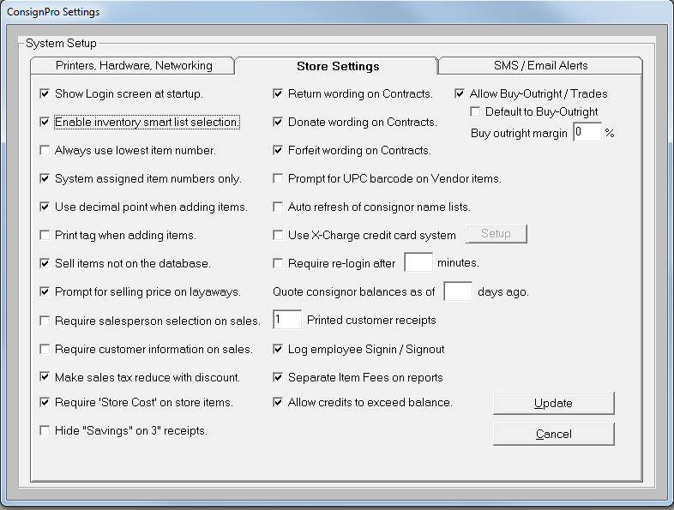
Show login screen at startup: If this box is checked, ConsignPro will display the login screen at startup, if not, the screen is bypassed and the Main Menu is displayed. Default is checked.
Enable inventory smart list selection: When this box is checked, the system will attempt to “guess” the entries on the list boxes on the “Add Inventory” screen when you begin to type into the fields. For example, when you type “Tom” into the “Description” box on the “Add Inventory” screen, the system might automatically find “Tommy Hilfiger” in the list so that the entire word does not need to be typed. Some store owners find this helpful, others find it annoying. It applies to the Type, Description, Color, and Size boxes on the Add Inventory screen.
Always use lowest item number: If this box is checked, ConsignPro will scan your database to find the lowest available item number that is not in use and use that number when you add a new inventory item. Subsequent “adds” will also attempt to find the lowest item number not currently in use. This feature was added to get the system “back on track” after a very large item number was mistakenly added to the system. Default for this box is “unchecked”.
If this box is checked and your item numbers are still too large, try un-checking it, clicking Update and then putting the check back in. This resets the numbering.
System assigned item numbers only: ConsignPro allows you to type in the Item Number on the Add Inventory screen. If you check this box, the system will not allow the user to type over the system assigned item number (either on purpose or by accident). This will ensure that all item numbers are used and none are accidentally skipped.
Use decimal point when adding items: This field is used to tell ConsignPro whether you will be typing the decimal point when adding new inventory items. If unchecked you can enter 1999 in the Rack Price field to represent the value $19.99. Default is checked.
Print tag when adding items: If you are using thermal or dot-matrix style tags or labels, ConsignPro can automatically print an inventory tag when you add inventory to the database using Add Inventory. If you do not use this option, tags and labels can be printed from the Reports page.
Sell items not on the database: If this box is checked, you can sell items that are not on the ConsignPro database using only the consignor number (or name) and the amount on the “Make Sale” screen. If un-checked, the system will bring you from the Make Sale screen thru the Add Inventory screen (slower) before the item can be sold.
You can sell an item not on the database by entering an “N” or “n” into the “Item Number” field on the “Make Sale” screen and pressing the tab key. More information this can be found in the “Make Sale” section of this guide.
Note: For the most accurate record keeping it is suggested that you enter all inventory into the database before selling it. This makes ConsignPro reports accurate and detailed. ConsignPro will add the item otherwise with a Type, Description, Color, and Size of “None”.
Prompt for selling price on layaways: ConsignPro can prompt you on the Make Sale screen for the current selling price of an item that is being put on layaway. Most store owners use this feature so that the correct price can be recorded when the item is being put on layaway.
Require salesperson selection on sales: If you are paying commission to salespeople, use this checkbox to ensure that a selection is made in the “Salesperson” box before the sale is completed on the “Amount Due” screen.
Require customer information on sales: If you require the collection of customer data (name, address, etc) during the sale (POS) process, you can check this box. The sale cannot be completed until customer information is entered on the Amount Due screen.
Make sales tax reduce with discount: If checked, the sales tax calculated on the Amount Due screen will reduce when you enter a discount.
Require Store Cost on store owned items: If checked, you must enter a “Store Cost” on the Add Inventory screen before you save a Store item. Otherwise, the cost can be zero.
Hide “Savings” on 3” receipts: If checked, the “Savings:” line will not appear on the Star 3” receipts that print.
Return wording on contracts: If checked the “Return to consignor” check box appears on the top of the consignor contract. You should only use this checkbox if you give the consignor the option of having the item(s) returned at the end of the contract period.
Donate wording on contracts: If checked the “Donate items” check box appears on the top of the consignor contract. You should only use this checkbox if you give the consignor the option of having the item(s) donated at the end of the contract period.
Forfeit wording on contracts: If checked the “Forfeit” check box appears on the top of the consignor contract.
Prompt for UPC barcode on Vendor items: If checked, ConsignPro will prompt you to scan the barcode on the Vendor item you’re adding on the Add Inventory screen. You can then use that product barcode on the Make Sale screen when you sell the item. This is helpful if you don’t want to retag those items that already have UPC or retail product barcodes on the item.
Auto refresh of consignor name lists: This is for our networked customers who want the consignor name lists to refresh every time they add or change a consignor name on the system. This can be helpful if you add a consignor on the back computer and then want to look them up (by name) on the front computer. ConsignPro automatically refreshes name lookup lists when it is started each morning. Using this feature may slow the system down.
Use X-Charge credit card system: ConsignPro can integrate with X-Charge credit card software (available from us) to process credit card transactions using ConsignPro and the modem on your computer. More information about this program can be found in the Amount Due section of this User Guide or on our website at www.consignpro.com/ccard.php.
Setup: This button is used in conjunction with the X-Charge Support Team to setup the X-Charge server information. Their number is (800) 338-6614.
Require re-login after XX minutes inactive: You can have the Main Menu timeout and return to the Sign-on screen using this feature. This is helpful for store owners that have several employees setup with different permission levels.
Quote consignor balances as of XX days ago: When you click the Payout Balance button on the Find Consignor screen, the current balance is shown. If you’d like to the balance to reflect the balance as of, for example, 5 days ago, enter 5 in this box. This can be helpful for stores who have a refund policy and don’t want to pay consignors too soon for items that could be returned.
xx Printed customer receipts: This determines how many sales receipts are printed during the Make Sale process.
Log employee Signin / Signout: When checked, every employee who uses the Signin screen to access the system will be recorded in the Usage Log (available under the Tools menu above the Main Menu).
Separate Item Fees on reports: If checked, any Item Fee that is removed from the consignor’s portion of the split are broken out and shown to the consignor separately on Payout and Account Activity Reports. If you don’t want the consignor to see this breakdown, remove the check. If you’re unsure, leave it unchecked.
Allow credits to exceed balance: If checked, a consignor who buys items from you can use more consignor credit than they have available to pay for their purchase. This will set their balance into a negative (debit) position until more of their items are sold.
Allow Buy-Outright / Trades: If you’re store is going to be buying items outright from customers, check this box. This will then give you a special type of inventory selection on the Add Inventory screen (Buy-outright item). The system will automatically calculate the amount to pay for the item (based on the “Buy outright margin” setting and put the money you’re paying for the item(s) into the consignors account.
Note: If you’re doing primarily buy-outright in your store, check the “Default to Buy-Outright” box and that entry will be selected automatically on the Add Inventory screen.

SMS / Email Alerts tab

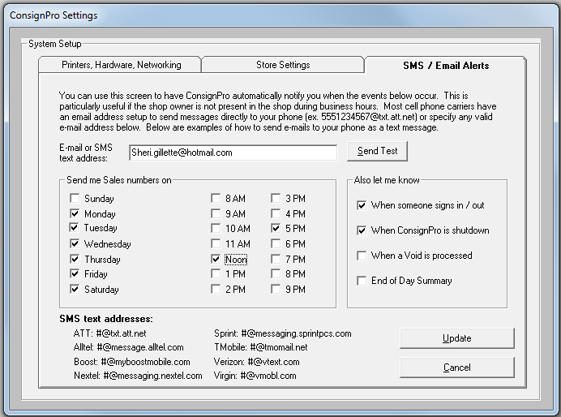

This screen can be setup to send sales data to your cell phone (assuming you have SMS text messaging). To start, enter your SMS text address or email address. Sample SMS addresses for most major carriers are at the bottom of the window. Each contains your cell phone number with carrier .com addresses. You can also enter a valid email address if you can receive email on your phone.

In addition to sales data, ConsignPro can also let you know when someone logs in/out, ConsignPro is shutdown, a void is processed, or end of day totals. This is a great feature if you’re not in the store everyday or run more than one store.

ConsignPro must be running at the designated times for these features to work. Use the Test button to be sure your address is set correctly.

Important: Before you can use this screen, you must setup the Postman screen with your SMTP Server and Port number from your ISP. You can do this on the Main Menu, at the top, Internet, Email VHS Support. Once you can send us a test message, you’ll be able to use this feature.

ConsignPro Remote Data Loader

Our newest version of ConsignPro allows you to enter inventory on the Internet and have those items show up in your ConsignPro database file.

To setup this feature, after ordering it from us, click the “Remote Data Setup” button on the Maintain Store screen. You will see this screen.

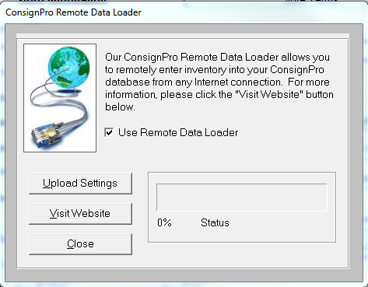

Our Support Team will help you turn this feature on and then click “Upload Settings”. This will upload your list entries to the Internet where they can be used when you log in to enter inventory (www.consignpro.com/remote)

After you’ve entered some item via our website (or your employees, or your consignors), above the Main Menu, click “Internet”, “Get Remote Data”. When completed, the following screen will appear.

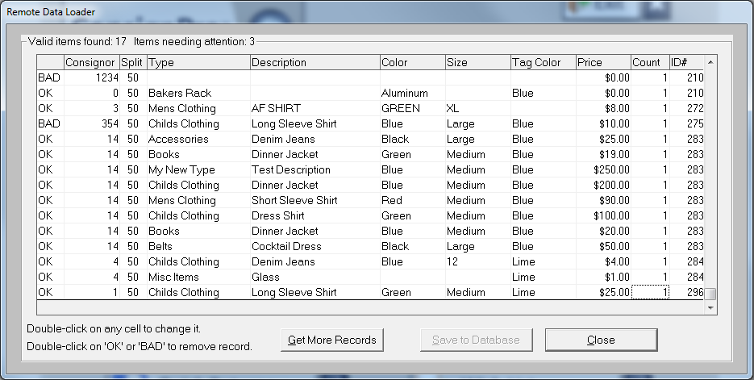

This screen can be used to correct entries (double click on any cell to change it) or remove any “Bad” records. Once all the records are “OK”, you can click the “Save to Database” button. ConsignPro will import the items into the database and tags for those items can be printed from the Reports screen (using the “Any Unprinted” check box).

Customer Wish List

The following screen shows the customer wish list. If items are entered into the wish list, ConsignPro will compare them to current inventory to find matches. Any combination of the lookup fields (Type, Description, Color, and Size) can be used.

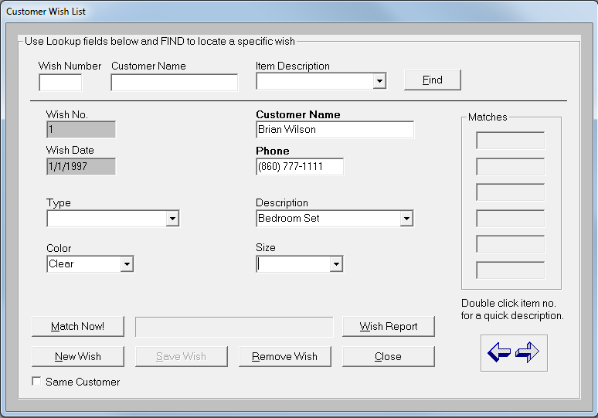

Wish List Fields

You can lookup a wish by wish number, customer name, or item description and the Find button. Enter only one of these fields before clicking Find.

Wish No: A unique number identifying the wish. This is set by the system.
Customer Name: The customer requesting the item.
Phone: The phone number of the customer requesting the item.
Type, Description, Color, Size: Fields used to identify the item wanted. Any combination of these four fields can be used to describe a wish. All selected fields must match database fields before a match is shown. Selecting “Clear entry” from the list will clear list entries.
Note: You have the option of either selecting a list entry using your mouse or typing in all or part of a phrase. For example, to match all of the “jeans” in your store you can simply type the word “jeans” into the Description box. This will bring back “Calvin Klein jeans”, “Levis jeans”, “Lee jeans”, etc.
Matches: A list of item numbers on the database matching the wish criteria. This list is updated when the “Match Now” button is pressed if any matches are found on the database. To see a quick description of the item, simply double-click on the item number in the list!!

Wish List Buttons

Match Now: Causes each wish to be compared against inventory items on the ConsignPro database. Wish matches appear in the match list. This process may take several minutes and uses a progress bar to show completion percentage.

New Wish: Enter a new wish onto the database.

Save Wish: Save wish entered after using the New Wish button. Customer name, phone and either a Type or Description must be selected before a wish is saved.

Remove Wish: Removes a wish from the ConsignPro database. Wishes should be removed after the wish is “satisfied”.

Wish Report: Prints a Wish Report to the default printer containing wish information and any matches that are found. Customers can then be called and sales made!

Close: Closes the Wish List window.

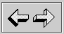 Used to scroll through wishes on the ConsignPro database. The sample wish can be removed only after a new wish is added.

Quick Returns

The Quick Return screen is shown below. Quick Returns can be used to quickly move inventory items from one status, typically “Available” to another, typically “Donated”, “Returned”, or “Expired”.

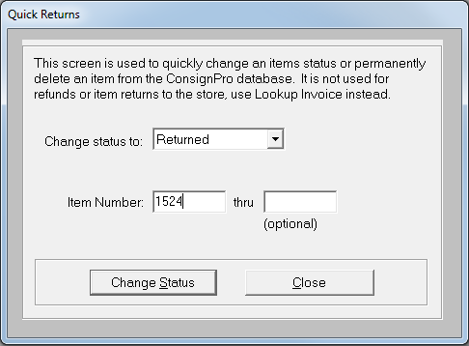

To use quick returns simply do the following:

Enter the new status from the drop-down list.
- Type in the item number that you’d like to change the status of.
- Hit enter or click “Change Status”. A word in red, “Changed” appears to the right of the Item Number if the change was successful!
Note: Only “Available”, “Expired”, “Missing”, or “Store” items can have their status changed using this screen. If changing an item status TO “Store”, the system will prompt you to make sure you are using the correct store account number.
Note: To change an item’s status from a “Final” status (sold, returned, donated, etc), you can look up the individual item and press the F10 key to unlock the status field and then change it. In general, we do not recommend this unless it makes sense in your situation.
Using the Re-Consign list selection – You can elect to re-consign an item using this screen. If you do, ConsignPro will reset the end date on the item and, optionally, have the tag print again and reset the markdown periods so the item continues to mark down. These boxes appear when you select “Re-consign” from the list.
Note: Be careful using the item number ranges as this will change MANY items at once. This cannot be undone.

Hardware Options

The following hardware options are available with ConsignPro. This screen can be seen by clicking on “Help” / “Hardware Options” on the Main Menu. More info on all pictured items can be obtained by calling us at: (888) 721-9767.
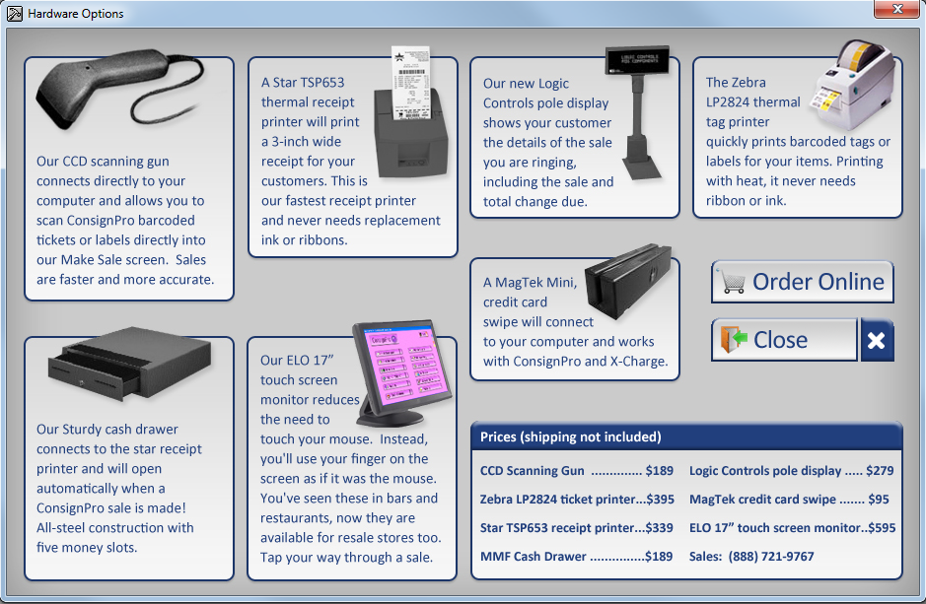

Printing Checks

The printing PC must be the only PC running ConsignPro before checks are printed. The following screen appears when you click the Print Checks button on the Maintain Store screen.
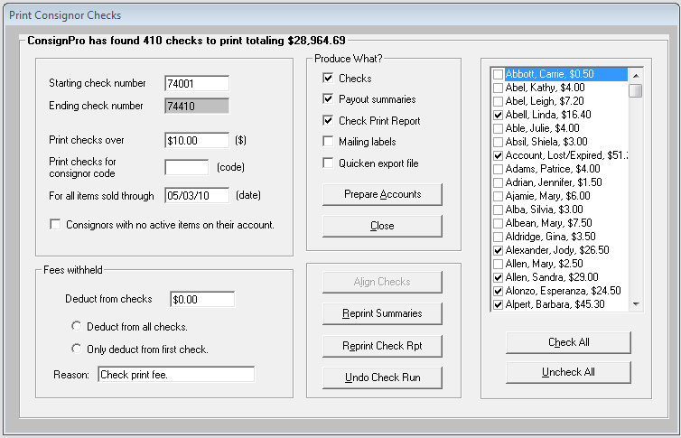
Each field on the Print Checks screen is reviewed next. Note that the frame around the screen always maintains the number of checks and the total check amount.

Fields on screen

Starting check number – This field should be used to specify the first check number that is in your printer. ConsignPro records check numbers for each consignor who receives a check. This information is found on the Account Activity screen after the checks are printed.

Ending check number – The system automatically calculates this number based on the starting check number and the total number of checks being produced.

Print checks over – This field is used to set a minimum check amount for each check produced by the system. In our example, above, no checks for less than $10 will be printed. If you change this field, press Tab and the system will recalculate the checks that will be printed on the frame surrounding this window.

Print checks for consignor code – If you use this field, ConsignPro will only print checks for those consignors who have the consignor code that you enter. For example, you can print checks for just those consignor accounts with a Consignor Code of “ABC”. The consignor code field is set on the Find or Add Consignor screens. If you change this field, press Tab and the system will recalculate the checks that will be printed on the frame surrounding this window.

For all items sold through – If you enter a date in this box, ConsignPro will only payout consignor balances as of a certain date in the past. For example, if the date is May 15th and you are printing checks, you can type in 05/03/10 and the system will not pay consignors any money for items sold AFTER May 3rd. This money will remain in their account and presumably be paid during the next system payout.

Deduct from checks – If you charge your consignors a fee for producing and mailing a check, you can enter this amount in this field. This appears on the consignor Account Activity or Payout Summary report with the reason you specify in the Reason field (30 characters maximum). If you change this field, press Tab and the system will recalculate the checks that will be printed on the frame surrounding this window.

Deduct from radio buttons – You can elect to deduct money from all consignor checks being printed or only from the first consignor check produced for a new consignor.

In the above check-printing example, ConsignPro has found 410 checks to print with balances over $10. This resulted in a check payout total of $28K+.
ConsignPro automatically tracks starting and ending check numbers. The check number in the starting box should be the same as the check number on the first check in your printer’s paper tray.

Check boxes on screen
Several check-boxes appear that can be used to tell ConsignPro exactly what you would like to print. You have the option to print checks, payout summaries (statements), a Check Print Report, Mailing labels, or export data to Quicken. A description of each option is given next.
Checks: Check this box to physically print consignor checks. Consignor checks are printed on Quicken compatible check stock in your printer. You can purchase Quicken compatible checks for most types of printers and set the type you’ve selected on the Customize CP screen in the “Check style” box. More information on ordering checks is found below.
Payout Summaries: An account statement for each consignor who is receiving a check. This statement shows all changes to a consignors account balance since the last check was printed.
Check Print Report: A report that shows every consignor receiving a check with the check amount. The report is totaled and usually kept by the store for record keeping purposes.
Mailing Labels: The print mailing labels checkbox will print labels on Avery labels (30 per page). ConsignPro prompts you before printing labels so that you can add labels to the printer paper tray.
Note: All checks and statements in ConsignPro now have the address printed on them. This will, in most cases, eliminate the need for mailing labels. Addresses show through standard windowed envelopes.
Quicken Export File: ConsignPro can produce a Quicken Interface file (iif file) for all check transactions. This file will be saved to your hard drive in the location you specify. You can then “import” the transactions into your Quicken program using the import function. For more information on importing transaction files into Quicken, consult their reference guide.

Buttons on screen
Prepare Accounts -- Once you have set the check selection criteria to meet your needs, click then Prepare Accounts button to mark the correct accounts on the database and recalculate check amounts (in the case of only paying thru a certain date). This button then changes to “Print Selected”
Print Selected -- Click this button to start the check run and print or produce the output you selected using the check boxes above.
Close – Returns you to the Maintain Store screen.
Align Checks -- This button is enabled if you are printing checks on a dot-matrix style printer and need to print a test check for alignment purposes. This button is disabled if you are printing to an Inkjet or LaserJet printer as no alignment is needed.

Check All and Uncheck All – These buttons will either select all account or remove the checks from all accounts. You can then manually select accounts using the check boxes to the left of each consignor’s name.

Reprint Summaries -- This option can be used to reprint consignor statements for any given check run. You’ll need to know the date that checks were originally printed on.

Reprint Check Rpt -- This option can be used to reprint the check print report for any given check run. You’ll need to know the date that checks were originally printed on.

Undo Check Run – This button can undo any check run that you’ve previously accepted. It will restore consignor account balances and remove any activity records associated with the original check run. You’ll need to know the date that checks were originally printed on.

Producing Checks
After verifying that the starting number is correct, selecting the correct consignors, selecting what you’d like to print, and placing check stock in the printer tray, click on print. ConsignPro asks that you verify your options:

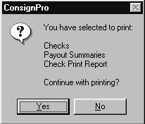Click “Yes” to continue printing or “No” to cancel printing. After printing checks, ConsignPro credits consignor account balance by the amount of the check and writes the payment to the consignor’s account activity log, complete with the check number.
If your printer jammed, or the check run did not work correctly, ConsignPro will give you the opportunity to re-print checks.
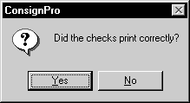
Clicking “No” will undo the account balance updates and allow you to re-print checks.
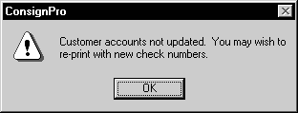
Clicking “Yes” will update the account balance and optionally print a “Check Print Report” detailing all checks that were printed as part of this run. This report should be kept for record of payment. In addition, ConsignPro will optionally print a “Payout Summary” report for each consignor that received a check. This report details all account activity since the last ConsignPro check was printed.

Ordering Check Stock

ConsignPro will correctly align printing on Quicken™ “standard” check stock. Quicken™ check stock can be ordered directly from Forms Plus by calling their order line at: 1-800-241-2319. The representative will ask you for store information and checking account numbers. Be sure to order the “standard” stock (3 checks per page) or voucher style checks (1 per page) if you plan to pay consignors individually.

List Maintenance

List maintenance allows you to customize the ConsignPro program to meet the individual needs of your store and its inventory. Six lists are provided for you to customize: Inventory Type, Description, Size, Color, Payment Types, and Tag Colors. To complete these lists you should first think about the Types of inventory that your store accepts (ex. Men’s Clothing, Furniture, Toys, etc.) and then, more specifically, the descriptions (ex. Shirt, Desk, Ball, etc.).
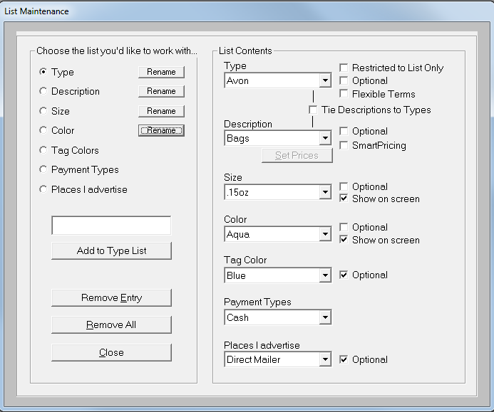
Above is a sample list maintenance screen.

Updating User Lists
You can add or remove items from each of the five lists. Each of the inventory lists is “optional”. By making a list optional, you do not need to make a selection from it when adding new inventory. Any optional list that is not selected from will default to “None”.
Note: Keep in mind that you can report on your inventory by either Type or Description so you may want to choose your categories carefully so that your reports are more meaningful.

List Maintenance Fields

Which List?: This list of “radio buttons” is used to select the list you’d like to add to or delete from. Select the list before making any changes to it.
Add to xx List: Specify the item you’d like to add to the selected list here. Then click on the “Add to…” button to add your item to the list. ConsignPro automatically capitalizes item names for you.
List Contents: Drop-down lists show you exactly what items are in each of the lists. The contents of the “selected” list changes as you add or remove entries from it.
Restricted to List Only: If checked, users can only select the Types that are in the list on the Add Inventory screen. Users cannot type in their own entries.
Tie Descriptions to Types: This checkbox causes the Descriptions list to work in conjunction with the Types list. For example, if you want the entries you see in the descriptions list to automatically change based on the Type you select (on the Add Inventory screen), you should tie these two lists together. If not tied, each list will work completely independent of the other.
Note: If you tie these two lists together, all the Descriptions will be erased. You will need to re-enter the Descriptions after selecting the Type you’d like the individual Description tied to.
Optional: Check this box if the field is not required when you add inventory. Furniture consignment may have no need for “Color”, for example. They would make the color list optional. If you choose to make a list optional, you must have an entry in that list of “None”. ConsignPro will ask you to add one if you don’t.
SmartPricing!: Using “SmartPricing” will allow you to assign a 3 prices to each inventory description that you enter (Low, Med, and High). These prices are then shown on the “Add Inventory” screen when an item with that “description” is added. Store owners can use this feature to set suggested inventory prices on certain items so that store clerks who add inventory do not need to know pricing rules. Prices can always be changed when an item is added to inventory. Click the “Set Prices” button to set smart prices for each item in the Descriptions list.
Flexible Terms: This feature allows you to set the consignment terms based on the Type of the consigned item. The terms that you can set are split percentage, length of consignment period, and markdown terms.
You would use this feature if you the terms in your store differ based on the type of item being consigned. For example, one of our customers consigns bridal dresses and regular clothing. Bridal dresses have a longer consignment period and different split percentage than non-bridal inventory.
With Flexible Terms, she can add a Type called “Bridal Fashion” and set the terms for that Type of item. When an item is added to the database and “Bridal Fashion” is selected from the Type list, the terms she setup for that Type will automatically be assigned to the item. Non-bridal items will default to the terms set on the Maintain Store screen.
When you turn on Flexible Terms and then select an entry from the Type list, the following screen will appear:
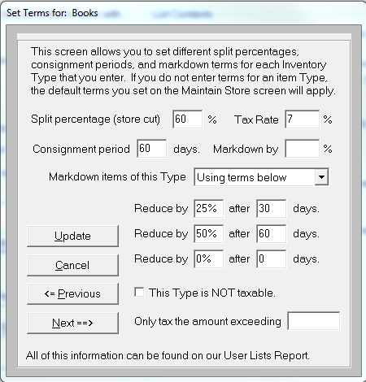
Each field on this screen is now described.
Split percentage (store cut) – Enter in the split percent that the store receives when an item of this Type is sold.
Tax Rate – If the tax rate for this Type differs from your store default, you may enter the tax rate in this box and the Type will be taxed accordingly.
Length of consignment period – Enter in the number of days you typically consign this Type of item.
Markdown by: -- If you’d like to do, for example, a one-day sale on this “Type” of item, you can put the discount into this box and any items sold will be subject to this markdown percentage. If you remove the entry, the item will sell for its current price (without the markdown).
Markdown items of this Type – Set the markdown terms for items of this Type or let them default to the terms on the Maintain Store screen or have this Type of item Never be marked down.
This type is not taxable – If you select this, the item will not be taxed when it is sold. This could be useful if you sell Furniture and Clothing and the furniture is taxed but the clothing is not. You can setup each as a type and set the taxable option once here.
Only tax the amount exceeding – Some states only tax clothing items where the price of the item exceeds $75. If this is the case in your state, you can enter the amount into this box for this Type.
Use the “Update” button to save your changes or “Cancel” to return to the List Maintenance screen without saving your changes. You can also scroll through the different item Types and set the terms for each using the Previous and Next buttons.

List Maintenance Buttons
Rename: Each list title can be renamed. If you rename a list (ex. Change “Type” to “Dept”) the new heading will appear on the Add / Find Inventory screens. This can be helpful for training purposes but it will not change the headings on reports and has no real effect within the program.
Remove Entry: Will remove the displayed entry from the selected list. Lists are selected in the “Which List?” box and items are selected by clicking on the drop down list and selecting the item you’d like to remove. Each list must contain at least a single list entry, even if the entry is “None”.
Remove All: Removes every item from the selected list. Each list must contain at least a single list entry, even if the entry is “None”.
Close: Returns you to the “Store” screen.

QuickBooks Data Bridge

ConsignPro can interface sales information to the QuickBooks program by Intuit. QuickBooks is not included with your ConsignPro purchase but can be purchased in any office supply store for under $200. Consult your accountant or bookkeeper for the best version for your business and setting up the correct accounts to use.

Currently, ConsignPro can interface with any desktop version that is installed on your computer. We do not interface with their “online” versions.

To start, click QuickBooks from the top menu and click either “Export Sales” or “Export Consignor Checks”. Doing so shows the following screen:

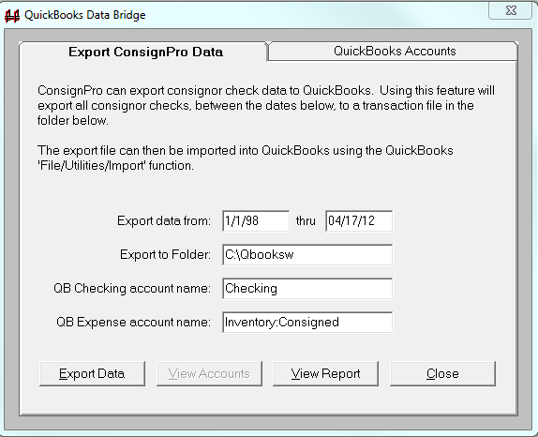

Exporting sales data

ConsignPro can export sales information from your system from a start date through an end date. You should also specify the folder where ConsignPro should save the transaction file that is created during the export. While the name of the folder doesn’t matter too much, knowing where the data is being saved does as you will need to access that during Step 2.

Before exporting any data, you should view the QuickBooks accounts (“View Accounts” button) where ConsignPro is going to send sales data. Aligning the two programs is critical for the two programs to work together. The QuickBooks Accounts “tab” is shown next.

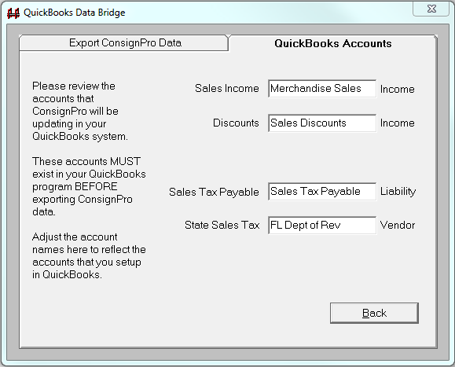

As you can see, there are four accounts that ConsignPro will update in QuickBooks. The names on this screen should be exactly as they are setup in your QuickBooks program. If similar accounts do not exist in your copy of QuickBooks, you should establish them BEFORE running the export. The TYPE of account (Income, Liability, and Vendor) must also match QuickBooks.

The first three accounts were already in our “chart of accounts” when we installed QuickBooks Pro 2012 for use in a “Retail” business. We didn’t need to add those. The 4th account (Sales Tax Vendor) should be a “Vendor” that you setup in QuickBooks, specifically the state agency that you pay sales taxes to (ex. Dept of Revenue).

When the accounts are correctly identified you can return to the Export “tab” and click the “Export Data” button. This will create a file in the QuickBooks directory with an .iif extension and produce an Export Report that can be viewed and then printed.

The report contains detailed information about the amounts that were posted to each account and gives the name of the interface file that was written to the QuickBooks directory.

After the export is complete, you can start QuickBooks and perform STEP 2 -- the import. To import the ConsignPro data, simply click “File” / “Utilities” / “Import” / “IIF Files” in QuickBooks and select the file name that was printed on the latest “QuickBooks Output Report” and then click OK.

Note: We strongly recommend that you backup your QuickBooks database before importing any data from ConsignPro. This will insure that you can restore your old data if there is any problem with either the import process or the data that you exported from ConsignPro. For more information on backing up the QuickBooks database, see the QuickBooks Reference Guide.

Some important tips:

- In QB, be sure you have a “Customer” named “Walk In Customer”. You should see this customer when you click the ‘Customers’ button in QB. In some instances, you will see the customer under “Lists / Other Names List”. If you see “Walk in Customer” in that list, delete or rename them there and add them in under “Customers & Jobs” as a new customer.
- Under Edit, Preference. Click “Sales Tax”, “Company Preferences”. Under “Do you charge sales tax”, click “No”. ConsignPro calculates and passes the sales tax to QB so there is no need to have QB recalculate it for you.

Exporting Consignor Checks

The check export is similar to the sales export but it exports consignor checks created by ConsignPro. You select the export from and thru dates and the folder where you would like ConsignPro to place the export file.

You can also select the “QB checking account name”; this is the name of your checking account in QuickBooks. If you would like to specify the Expense account that ConsignPro credits for each transaction you can do so on this screen. Our default account is Inventory: Consigned.

When the export is complete you can view a report of the checks ConsignPro has exported and the data file it has created during the export.

After the export is complete, you can start QuickBooks and perform STEP 2 -- the import. To import the ConsignPro data, simply click “File” / “Utilities” / “Import” / “IIF Files” in QuickBooks and select the file name that was printed on the latest “QuickBooks Output Report” and then click OK.

Note: We strongly recommend that you backup your QuickBooks database before importing any data from ConsignPro. This will insure that you can restore your old data if there is any problem with either the import process or the data that you exported from ConsignPro. For more information on backing up the QuickBooks database, see the QuickBooks Reference Guide.

Exiting ConsignPro

If you select the “Exit” button, ConsignPro will prompt you with:
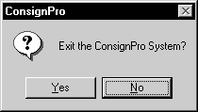
If you select “Yes”, ConsignPro will begin its “shutdown” operations. Entering “No” will return you to the Main Menu.

Shutdown Operations

ConsignPro will perform many functions at the end of each day. The operations all occur during shutdown. Shutdown operations require your PC to be the only one in the store running ConsignPro (close any networked copies you may have running).

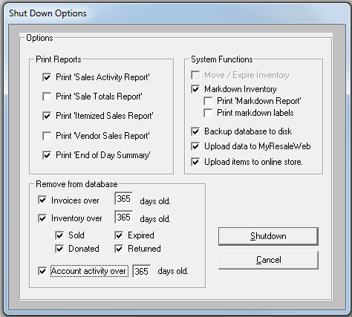
The shutdown operations screen provides you with many options at shutdown. We will now explore each of these operations in more detail.
Print ‘Sales Activity Report’: This option prints the “Sales Activity Report” which shows sales activity for the day broken down by invoice number. This report can be produced for any time period by using the Reports screen.
Print ‘Sale Totals Report’: This report shows your daily sales totals broken down by payment type. This is particularly handy for balancing your cash drawer at the end of the day. This report can be produced for any time period by using the Reports screen.
Print ‘Itemized Sales Report’: This report shows every item that was sold in your store, sorted and grouped by the consignor who owned the item. It also shows what the item was sold for and the total amount of all sold items for that day. This report can be produced for any time period by using the Reports screen.
Print Vendor Sales Report: This report shows the days sales of any “Vendor” items that may have been sold. The report is summarized by vendor and then vendor item number. This report can also be produced for any time period on the Reports screen.
Print End of Day Summary: The end-of-day report is a one page financial summary of the activity for that day. This report is also available on the Reports screen for any time period. If you have a 3” receipt printer, the report will print on that printer.
Move/Expire Inventory: If you have setup the special options to automatically move or expire items past their End Date, you’ll want to check this checkbox. Shutdown operations perform the moving or expiring of inventory.
Markdown Inventory: This option uses the markdown options on the store screen to automatically reduce prices on inventory items. Only items in status “Available” will be automatically reduced. If you would like to exempt an item from markdown, key a price equal to the rack price into the “Lowest Price” field on the inventory screen for that item or simply check the “Never reduce’ checkbox. If entering a lowest price, the “Lowest Price” becomes the minimum price ConsignPro will markdown to.
Print Markdown Report: If checked and items are found to mark down, ConsignPro will print a report of these items.
Print Markdown Labels: If checked and items are found to mark down, ConsignPro will print new inventory tags or labels for the marked down items.
Backup database to disk: The backup feature allows you to back your ConsignPro database up to diskette. This option is very important and should be done daily. If your database ever becomes corrupted or your hard-drive fails, this will be your source of backup protection. I recommend keeping at least one-weeks worth of back-ups at all times.
Note: The database name is “consign.mdb”. If the backup option fails, for whatever reason, you can manually back this file up from the ConsignPro directory under Program Files.
More information on backups can be found at: www.consignpro.com/backup.php
Upload data to MyResaleWeb: If you sign up for our web based service, you will see this new checkbox. When checked, you will be presented with a new screen that allows you to upload data to our MyReasleWeb internet site. More info on this service can be found at: www.consignpro.com/mrwinfo.php
Upload data to online store: If you sign up for an online store, ConsignPro will upload the pictures, prices and descriptions of the items you’d like to sell online in your very own online store! Sample: http://www.myresaleweb.com/stores/bk100/
Remove invoices after xx days old: This option will help keep your ConsignPro database at a manageable size by removing old invoices. You can specify how long you would like to keep old invoices. The default is 1 year.
Remove inventory over xx days old: This option will also help maintain the database by removing inventory items that are no longer in stock. You can specify how long you would like to keep sold, donated, returned, or expired items. The default is 1 year.
Remove account activity items over xx days old: This option will also help maintain the database by removing consignor account activity records. You can specify how long you would like to keep old account activities. The default is 1 year.
Note: You should keep the “Remove from database” boxes checked as it helps to keep your database file at a manageable size and performance level!

Canadian Customers

ConsignPro supports those functions that make Canadian use different from US use. If you are a Canadian customer, click the “Canadian Use” checkbox on the “Store” screen.

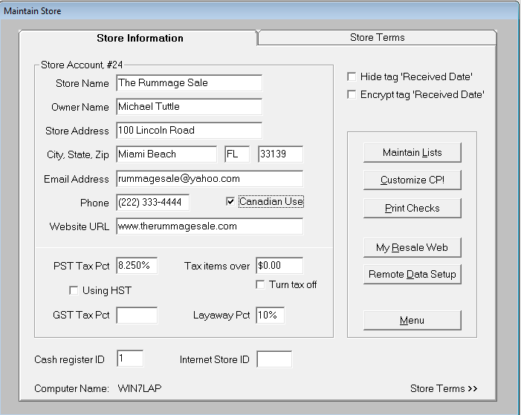

You will notice that when you check the “Canadian Use” checkbox, the “State Tax Pct” field changes to “PST” new fields “GST” and “HST” appears.

PST Tax Rate: The applicable percentage of PST for your province. This amount should be entered as a decimal (ex.07 for 7%). ConsignPro will calculate the amount of provincial tax due during a sale using this percentage. If provincial tax is not applicable, this field should be 0.00.

GST Tax Rate: The applicable percentage of GST (Goods and Services Tax). This amount should be entered as a decimal (ex .10 for 10%). ConsignPro will calculate the amount of federal tax due during a sale using this percentage. If GST tax is not applicable, this field should be 0.00.
Using HST: If you’re located in a province of Canada that is subject to a Harmonized tax, check this box. Enter the HST tax rate and the PST tax rate. ConsignPro automatically calculates the GST as the difference between the two.

Tax Items Over: This is the dollar amount at which items are subject to both PST and GST. For example, if this field is set to $10, all items sold for over $10 will have the PST and GST check-boxes automatically checked on the “Make Sale” screen. You can, of course, de-select either the GST or PST check-boxes for any particular item that you sell.
For more information on the “Store” screen, please refer to the Store Maintenance section of this guide. For more information on the “Make Sale” screen, please refer to the Make Sale section in this guide.

Note: Canadian (and International) customers should also go into their Windows Control Panel and double-click “Regional and Language Settings”. Click the Customize button and the Date tab (up top). Make sure your Short Date style is set to “m/d/yy”.

More Information

More information about ConsignPro can be found at the following locations:

- Our homepage at http://www.consignpro.com/cpupdate.php provides Version Updates and Release Notes for members of our Annual Maintenance Plan.
- By calling our technical support line toll-free at: (305) 535-0959.

Tech support is free for three months following your registration date. After that you should subscribe to our Annual Maintenance Plan. This entitles you to version update and the best tech support in the business!

Efficiency Tips!

The following tips are provided to make using ConsignPro easier.

- If the ConsignPro screens don’t appear to fill the entire screen area, check your display resolution. To do this click Start, Settings, Control Panel. Within Control Panel, double click on Display. Click on the “Settings” tab. Make sure that the resolution is set at 800 x 600. If not, drag the selector bar to the left. Click on Apply and OK.
- Use the “tab” key to move between fields and buttons on the screen. When tabbing to a button, you can then press “Enter” to “click” the button!
- Use function keys (F1, F2, etc) to access screens from the main menu. A complete list of active keys can be found under “File” on our main menu.
- If a button has an underlined letter, the “Alt” key and that letter will “press” the button. Example: On the Find Consignor screen, the Find button can be pressed by holding down the “Alt” key and pressing “f” on your keyboard.
- The login screen can be bypassed by un-checking the “Show login screen at startup” checkbox on the CP Setting screen.
- If the “Task Bar” for Windows gets in the way, you can set it to “Hide” itself. To do this, click “Start”, “Settings”, “TaskBar”. Then check the “Auto-Hide” checkbox. The TaskBar will automatically drop off the bottom edge of the screen but can be found by dragging your mouse cursor off the bottom edge of the screen.
- You do not need to enter slashes (“/”) when entering dates. Simply key a six-digit date into any screen date field (ex. 080199) and ConsignPro will insert the slashes for you when you tab off of that field!

Printing with ConsignPro – Our How-To guide!

Printing with the ConsignPro system tends to be one of the more difficult things to set up correctly. Luckily, once the setup is completed, printing is simple and straightforward with little else that needs to be done.

We’ve taken the time to put together this document to explain how to setup printers and use them successfully with the ConsignPro system. Follow each of the four steps to understand how we use printers and how you configure them to work correctly with ConsignPro.

For starters, ConsignPro prints reports, tags / labels, receipts, and checks on a variety of printers such as inkjet, LaserJet, dot matrix, and thermal printers. We will go through both single and multiple printer setups and how to configure each type of setup.

Things you’ll be printing with ConsignPro:

Reports – ConsignPro prints reports on standard 8 ½” by 11” paper. Reports can print on inkjet, LaserJet, or dot matrix printers.

Checks – ConsignPro prints checks on either cut-sheet or continuous feed check stock. You can print on inkjet, LaserJet, or dot matrix printers. All checks used with our system need to be “Quicken compatible”. You can order checks for your store from Forms Plus at 800.241.2319.

Receipts – Customer receipts print on either 8 ½” by 11” plain paper or on our optional 3” thermal receipt printer. Three-inch receipts print much faster than the larger 8 ½” by 11” receipts. We sell the Star receipt printer, call us for details.

Tags / labels – ConsignPro prints inventory tags or labels (stickers) on inkjet, LaserJet, or thermal printers. Barcodes can be printed on any of these printers. Examples of each type (14 types offered!) of tag/label we offer can be seen at the end of this document or on the Internet at http://www.consignpro.com/tags.php. Deciding which tags or labels to use is the most important aspect to consider before selecting printer configurations.

ConsignPro POS Connections Guide

This guide contains all the information necessary to connect your new point-of-sale equipment to your computer. It should be used during the initial setup and if you need to connect the equipment to a new computer in the future (i.e. KEEP this guide!). If you find these instructions confusing, it may be best to hand them to a local computer technician in your area.

The guide provides complete setup instructions for the following:

- CCD scanning gun (p.1)  - Turning on bar-coding (p.2) | - Pole displays (p.9)  - Credit card swipe (p.9)
- Star receipt printers (p.3) | - Install X-Charge software (p.10)
- Electronic cash drawers (p.4)  - Zebra ticket printers (p.5)  - Connect multiple printers (p.8) | - Using special labels (p.11/12)  - Returning hardware (p.13)

Connecting the scanning gun

The CCD scanning plugs directly into an open USB port.

The scan gun should make a beeping tone as your computer starts. No special driver files or configuration is required with the scanner; it should work right out of the box. You can test the scan gun by going into the ConsignPro “Make Sale” screen and scanning any of the barcodes pictured in the back of the ConsignPro User Guide. The barcode should scan and the item number should appear on the screen (along with a “not found on database” message).

If the scan gun does not read the barcode:

- Make sure the scan gun is connected securely.
- Press the “trigger” on the scan gun to get the red scan light to appear.
- Look in the booklet that came with the scan gun and find a barcode in the configuration section (typically in the back of the guide) that reads, “Reset default” or “Set default”. Scan the “Start” barcode, then the Default barcode, and then the “End” barcode. Re-test.
- If the barcodes in the back of the ConsignPro User Guide scan but the ones that you print do not, the issue is print quality. Try to improve the print quality or density by looking at the options in your printers driver file in the Printers folder.

Note: The scan gun does not work with some wireless keyboards and laptop computers.

Turning on barcodes

If you do not have barcodes on your inventory tickets but have selected a tag style that has a barcode, do the following:
- Click on the Windows "Start" button located at the bottom left hand corner of your computer screen.
- Choose Settings / Control Panel (or just Control Panel if Windows XP).
- Double-click on the Fonts folder. If you do not see the Fonts folder, you may need to first click “Switch to classic view”.
- Up top, click File, and then click "Install New Font".
- Double-click on the top folder in the lower left corner (C:\). Then find the \Windows folder and double-click that. Then find the \Fonts folder and double-click that.
- In the list of fonts in the top window, find the two Skandata barcode fonts. These are in the list alphabetically under “Skandata” (scroll down).
- Single-click either of the two Skandata font files to select it. Hold the "Ctrl" key down on your keyboard and single-click the second file. Both will appear selected. Let the "Ctrl" key up and click the OK button.
- Click OK on the two warning messages that may appear and close all open windows.
Barcodes will now appear when you print inventory labels or tags to either the screen or printer. If the barcodes do not appear, try repeating the steps above and then restarting your computer.
Star TSP650 Receipt Printer

The Star receipt printer may plug into either a parallel printer port or an open USB port on the back of your computer.

Step 1 – Connect the Star receipt printer:

- Using the printer cable that was included with your printer, connect the Star receipt printer to correct port on the back of your computer.
- Plug the power cable that comes with the printer into the wall.
- Open the printer and insert a roll of paper into the printer (see below for paper specs).
- The green power light should appear. If you are using a TSP650 and the paper roll is low, the red error light will blink warning you the roll is low. This does not affect printer operation.

Step 2 – Install the Generic / Text Only printer driver:

All Star receipt printers require the “Generic / Text Only” printer driver to be installed in the Windows printers folder. You do NOT need to install any Star drivers to use this printer with ConsignPro.

- In Windows, click Start / Settings / Printers (or in Windows XP, Start / Control Panel / Printers and Other Hardware / View installed printers).
- Double-click “Add a printer” to open the “Add printer wizard”.
- Click “Next” and select the printer port that you connected the printer in the connection step above (usually a USB port).
- Click "Next" until you see a list of Manufacturers.
- Click "Generic" in the list and select "Text Only”.
- Continue with "Next" until this printer driver is installed. Do NOT rename this printer when prompted!

Note: If Windows cannot find the Generic / Text Only driver file, you can download it from our Support web page. The name of the file you need is “generic.exe”. It contains all the files necessary to install the Generic printer driver. Our support web page is www.consignpro.com/support.php

Step 3 – Configure ConsignPro:

- On the Main Menu, go to Maintain Store and click “Customize CP”.
- Change the “Print receipts on” box to your specific printer model.
- Click Update, then Menu.

You can test this printer by printing a sales receipt from the “Make Sale” screen when you complete a sale. If you do not get a receipt, make sure the printer is “online” and the “Print sales receipt” box is checked on the Amount Due screen.

Paper specs for the receipt printer

If you are using the TSP650, purchase 3 1/8” thermal paper rolls from any office supply store. If you have trouble finding receipt paper, try www.staples.com or www.officemax.com

Connecting the electronic cash drawer

The electronic cash drawer simply connects to the bottom of the Star receipt printer using the cable provided by the manufacturer. You may need to remove a small piece of plastic on the bottom of the receipt printer to expose the cash drawer port. The drawer will open automatically when the “Open drawer” button on the Main Menu is clicked OR whenever you complete a sale.

Keys are included with every cash drawer shipped and are often taped to the Styrofoam that the drawer ships in. Inspect all packaging carefully before discarding.

Once the drawer is connected, go into the Maintain Store screen in ConsignPro and then into CustomizeCP screen. Change the “Auto cash drawer” selection box to “Attached to receipt printer”. Click Update. An “Open drawer” button will now appear back on the Main Menu.

Note: The Star receipt printer must be turned on, online, and have paper in it for the cash drawer to work correctly!

Note: If the drawer does not open with the button on the Menu, try opening it with the key to make sure it is not off track.

Zebra LP2824 Thermal Ticket Printer

The Zebra thermal tag printer connects to your computer with the supplied USB cable.

Step 1 – Connecting the ticket printer:
- Using the cable supplied, connect the ticket printer to an open USB port on your computer.
- Plug the power cable that comes with the printer into the wall and connect the power supply to the printer.
- Open the printer and insert a roll of tags or labels into the printer. Thread the tags according to the instructions that accompany the printer.
- With the tags sticking out a little, close the printer lid and then turn the printer on using the power switch on the side of the printer.
Step 2 – Installing the Zebra printer driver:
All Zebra tag printers require the appropriate printer driver to be installed in the Windows Printers folder. Windows may install the correct driver file for you. If not, use the CD that came with the printer and follow the driver setup instructions included with the printer documentation.
At the end of this step, you should have a printer named “ZDesigner LP2824 Plus (ZPL)” in the Windows, Printers folder. Do not rename the printer when you install it.
If you need help installing the Zebra printer driver, you may contact Zebra Technical Support at 847-913-2259.
Step 3 – Setting the correct paper size for tags / labels:
After the printer driver is installed, you need to set the paper size correctly so that the printer knows what size tags or labels you have in it. To set the paper size:
- In your Windows Printers folder, right click on the ZDesigner ticket printer.
- Click “Printing Preferences”.
- Set the orientation, width, height, and unprintable area based on the type of tags or labels you purchased from Forms Plus
- If you are using the double-wide tickets (LBTH): Landscape, Width = 2.20, Height = 3.20, Unprinted = 0's
- If you are using the single "one-up" tickets: Portrait, Width = 1.60, Height = 2.30, Unprinted = 0's
- If you are using the 2 1/4" by 1 1/4" stickers (LBTH-ONE): Portrait, Width = 2.25, Height = 1.25, Right = .04
Step 4 – Configure ConsignPro to use the ticket printer:
- On the Main Menu go to Maintain Store then CustomizeCP screen.
- Set the “My ticket printer is” box to the “ZDesigner LP2824 Plus (ZPL)” printer.
- Set the "Tag / Label Style" box according to the tags or labels you purchased from Forms Plus
- If you are using the double-wide tickets (LBTH): "Zebra Tags, Liberty style, barcode"
- If you are using the single "one-up" tickets: "Zebra Tags, one-up, barcode"
- If you are using the 2 1/4" by 1 1/4" stickers (LBTH-ONE): "Zebra Tags, 2.25" by 1.25"

For help configuring your tags or labels, call (305) 535-0959 ext 2.
Connecting the MagTek credit card swipe
The card swipe either connects an open USB port.
The card swipe should work right out of the box. No special programming or software is required.
When you swipe a card, the magnetic strip should face toward the light on the swipe unit.

Connecting the pole display
Before connecting the USB cable:

- Insert the CD.
- Browse the CD using My Computer.
- Go into the “USB Driver” folder.
- Go into the Windows folder.
- Double-click Setup.
- Click “Virtual COM port driver” and click Install.
- Plug in the USB cable.
- When Add New Hardware wizard appears, allow it to install the driver, click “Continue anyway”.
- When done, go into Control Panel, System, Hardware tab, Device Manager.
- Locate Ports, double-click. Find “LCI USB Line Display PD3000 Comm Port”
- Right click on it, go to Properties.
- Click the Port Settings tab.
- Click Advanced.
- Change the “COM Port Number” to COM1.
- Click OK a few times.
- Unplug the USB cable, wait 10 seconds, plug it back in.
- Change the setting in ConsignPro to COM1.

Using other printers with ConsignPro
In general, ConsignPro can print to any full-page printer attached to your computer -- assuming that Windows can print to the printer. Any printer that you connect requires the correct printer driver software installed into your Printers folder. After you install any printer (using the Windows Add Printer wizard found in the Printers folder), you should try to print a Test Page from the driver file to ensure that Windows can use the printer.
In general, your report printer should be the "default" printer in Windows and should also be selected in the "My report printer is" box on the Customize CP screen.
Installing and Configuring X-Charge credit card software
If you are using X-Charge to process your credit card transactions, please complete these steps below.
- Install X-Charge software from either the X-Charge CD or from the
”XCharge” folder on the ConsignPro program CD. The file on our CD is “xcsetup”. Select all the defaults.
- Contact X-Charge tech support at 800-338-6614 to configure the software.

Configure ConsignPro to use X-Charge
Once the X-Charge software setup is complete, start ConsignPro, go to Maintain Store then CustomizeCP. Click the Store Settings tab at the top. Put a check in the “Use X-Charge credit card system” box and click Update. This completes the setup of X-Charge. The next time you select a credit card from the Payments Types list, the X-Charge swipe window should appear.
Configuring special 1 1/8" by 1" thermal labels
The thermal 1 1/8" by 1" stickers that are used with ConsignPro are available from Forms Plus at (800) 241-2319. The product code is JEWEL-S.
Once you have the labels, you must install another copy of the Zebra printer driver that you installed above. To do this, follow these instructions exactly:
- In your Windows Printers folder, click Add Printer.
- Select Local Printer, and then the correct USB Port.
- On the screen that asks for a Manufacturer, select ZDesigner and then ZDesigner LP2824.
- Click Next until prompted for the Printer Name.
- Name the printer "Zebra Small".
- Finish the wizard.
After the new "Zebra Small" printer appears in your Printers folder, right-click on it and select Printing Preferences.
Under SIZE, make the Width = 2.25 and the Height 1.12. Click OK to save your changes to the "Zebra Small" driver.
On the ConsignPro Main Menu, click Maintain Store, CustomizeCP. In the lower right, check "Also using 1" by 1" thermal labels". Click Update, then Menu. The next time you print tags/labels from the Reports page, you can check the box "Use 1" by 1" thermal labels" when that roll is in the thermal printer.

Configuring special thermal jewelry labels with ConsignPro
The butterfly style thermal jewelry labels that are used with ConsignPro are available from Forms Plus at (800) 241-2319. The product code is JEWEL-R.
Once you have the labels, you must install another copy of the Zebra printer driver that you installed above. To do this, follow these instructions exactly:
- In your Windows Printers folder, click Add Printer.
- Select Local Printer, and then the correct USB Port.
- On the screen that asks for a Manufacturer, select ZDesigner and then ZDesigner LP2824.
- Click Next until prompted for the Printer Name.
- Name the printer "Zebra Jewelry".
- Finish the wizard.
After the new "Zebra Jewelry" printer appears in your Printers folder, right-click on it and select Printing Preferences.
Under SIZE, make the Width = 2.20 and the Height .50. Click OK to save your changes to the "Zebra Jewelry" driver.
On the ConsignPro Main Menu, click Maintain Store, CustomizeCP. In the lower right, check "Also using thermal jewelry labels". Click Update, then Menu. The next time you print tags/labels from the Reports page, you can check the box "Use thermal jewelry labels" when that roll is in the thermal printer.
ConsignPro Hardware Returns
If you need to return any of the POS hardware we shipped you, please follow the instructions below to insure you receive proper credit for the return.
- Re-package the part(s) that you are returning as closely to the original condition as possible. Include all cables, manuals, CD’s, packing materials, etc. Repack in the original boxes if possible. Failure to follow this step, in full, will result in a 10% restocking charge.
- Include in the package(s) either a business card or your full name, address, and phone number. Also include any packing slip you may have received with your order.
- Ship the package(s) to the address below by either UPS or Federal Express. Record the tracking number(s). Do not ship regular mail.
- Email support@consignpro.com and sales@obiusa.com a listing of the items you are returning, your name, address, and the shipping tracking number(s). Also include your reason for the return.
- Unless the item arrived damaged, you are responsible for return shipping charges.
Ship all returned items to:
OBI Distributors
1322 Bell Avenue, Unit 1K
Tustin, CA 92780

Inkjet or LaserJet options (4):

Avery 4" by 1" label with barcode. The labels come 20 per page and can be purchased at almost any office supply store. This is our most popular label.  </small> | 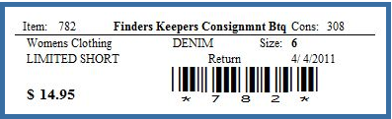
Avery 4" by 1" label with markdown information can be used to show automatic markdown information with the corresponding dates. The labels come 20 per page and can be purchased at almost any office supply store.</small> | 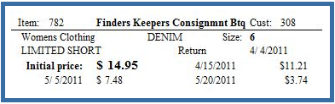
Avery 2 5/8" by 1" label with barcode is smaller than the one above but contains less information. These labels print on ink-jet or laser-jet printers and come 30 labels per sheet.  </small> | 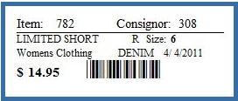
CP 4" by 1" tag is our only tag that works on Ink Jet or LaserJet printers. The tag is available from our tag vendor, Forms Plus in a variety of colors, (800) 241-2319.</small> | 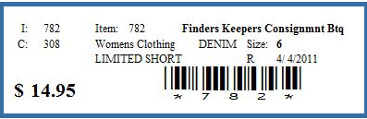

Thermal options for the Zebra thermal ticket printer (4):

Zebra “Liberty Style” thermal tag is 1” by 3 3/8” and is a 2-part tag. The tags come out of the printer two at a time with a top tag and a bottom tag. It is available from our tag vendor, Forms Plus, in a variety of colors, (800) 241-2319. | 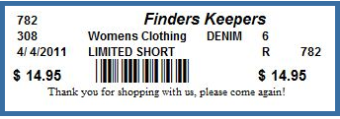
Zebra “Liberty Style” markdown tag is 1” by 3 3/8” and is a 2-part tag. The tag sacrifices the barcode but gives you time period markdown information. It is available from our tag vendor, Forms Plus, in a variety of colors, (800) 241-2319. | 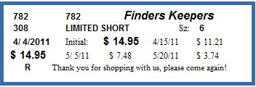
Zebra “Liberty Style” combo tag is a double-tag design (2” by 3 3/8”) that includes both a barcode and time period markdown information. It is available from our tag vendor, Forms Plus Inc, in a variety of colors, (800) 241-2319. | 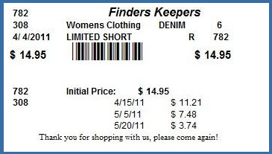
Zebra single thermal tag is 2 1/4" by 1 3/8". It is available from our tag vendor, Forms Plus Inc, in a variety of colors, (800) 241-2319.  Zebra 2 3/8 by 1 ½ one-up thermal tag prints in portrait and the tags exit the printer on at a time to minimize tag waste. The tags can be either setup for barcodes or markdowns.  Zebra butterfly-style thermal jewelry labels are available from Forms Plus. Labels are 2.20” by 1⁄2” and “wrap around” your rings and bracelets. Product code JEWLR.  Zebra 1” by 1” thermal label “squares” are available from Forms Plus. These stickers are perfect for smaller items. Product code JEWLS. | 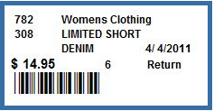  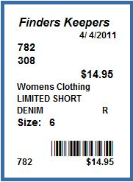  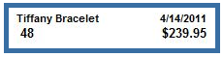  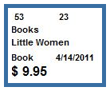

User Guide Index

account credits
using during sales, 59
adding
new consignors, 42
new inventory, 49
Amount Due
buttons on screen, 61
fields on screen, 59
screen, using, 58
barcodes
scanning into Make Sale, 53
Buyers fees
setting, 88
Canadian customers
special features, 127
cash drawer
using, 97
Checks
coding for a group, 33
individual, 37
ordering stock, 115
printing, 111
Consignors
account activity, 35
adding new, 42
adjusting account balances, 34
applying fees, 15
assigning codes, 33
assigning split percents, 34
buttons on screen, 35
checks, 111
contract message, 86
contracts, 37
deleting, 38
fields on screen, 33
finding, 32
return to, checkbox, 44
split percentage, 44
validate accounts, 25
contracts
contract message, 86
printing, 37
Customers
entering mailing info, 61
Mailing labels, 79
reporting, 80
selecting with criteria, 80
Customize CP
using, 96
customizing
user lists, 116
database
backing up, 125
file name, 125
purging old data, 126
default printer
specifying, 96
deleting
inventory items, 46
disk
menu, 14
Employees
adding and changing, 70
changing passwords, 70
exit. See Shutdown Options
Exiting
ConsignPro, 124
file
menu, 14
finding
consignors, 32
inventory, 43
Hardware
options, ordering, 110
Help
menu, 31
resources, 128
hints
efficiency tips, 129
Inventory
adding new, 49
automatic markdowns, 87
buttons on screen, add, 50
buttons on screen, find, 48
buyers fees, 88
changing status, 47
changing status quickly, 108
deleting items, 48
deleting items, 46
fields on screen, 44
finding, 43
item charges, 46
item numbering, 99
item status, 46
minimum price, 45
numbering, 49
options after consignment period, 97
price suffixes, 88
printing individual tags, 48
received date, 44
repeating similar items, 50
reporting on, 76
searching for, 77
selling items, 53
selling items not on database, 54, 100
setting an end date, 44
setting consigned period, 87
setting price, 45
SmartPricing!, 117
specifying colors, 45
specifying descriptions, 45
specifying sizes, 45
specifying types, 45
split percentage, 88
store owned items, 51
summary view, 37
tag color markdowns, 91
vendor items, 51
view items, 38
Invoice
looking up, 67
Item Charge
assigning, 46
Labels/tags
encrypting entered date, 85
finding lost, 77
ordering, 97
printing, 48
printing, 75
printing markdown labels, 125
Samples, 141
specifying sizes, 97
specifying type, 97
layaway
receipt message, 86
report, 75
selling an item on, 56
setting deposit percent, 85
status indicator, 46
using layaway, 55
Layaway
adding money, 18
changing money, 19
modifying existing, 16
put an item on, 56
removing a deposit, 19
List maintenance
buttons on screen, 119
fields on screen, 117
updating lists, 116
logging On, 9
login screen
bypassing, 99
mailing labels
printing, 79
main menu
buttons, 11
menu, 14
overview, 11
Make Sale
selling items, 53
Make Unprinted
button, 48
Markdown options
reducing items during sale, 55
specifying, 87
tag color, 91
Networking ConsignPro, 98
passwords
changing, 70
using, 9
payouts
consignor balances, 37
individual checks, 37
printer
assigning, 96
Printing
consignor checks, 111
consignor contracts, 37
How To Guide, 130
Troubleshooting, 130
Quick Returns
overview, 108
QuickBooks
exporting sales data, 120
menu, 31
Quicken
export file, 113
Quiting
ConsignPro, 9
receipts
re-printing, 69
specifying printer, 96
store message, 86
Removing
consignors, 38
inventory items, 48
invoices, 68
items from a sale, 54
Reports
Activity report, 36
Aged Inventory, 76
Consignor Balance, 77
Consignor Payouts, 75
Customer Report, 80
Income Statement, 75
Inventory Labels/tags, 75
Inventory Report, 76
Itemized Sales Report, 74, 125
Layaway Report, 75
Mailing labels, 79
Markdown Report, 79
Received report, 37
Sale Totals Report, 125
Sales Activity Report, 125
Store Activity, 74
User Lists, 79
Wish List, 107
Reprinting
checks, 111
Selling items, 53
Settings
changing, 96
fields on screen, 96
shortcut
keys, 13
Shutdown
options, using, 124
SmartPricing!
using, 117
status
changing, 47
Store
fields on screen, 85, 86
maintaining store info, 84
Store items
adding, 51
introduction, 47
Support
getting help, 128
Tag Color
assigning, 46
markdowns, 91
tags/labels
ordering, 97
printing, 75
Tax
federal, Canadian, 127
Provincial, Canadian, 127
selling taxable items, 55
state, changing, 85
what's taxed?, 85
Tips
efficiency, 129
tools
menu, 14
user guide
welcome message, 5
Vendor items
adding, 51
introduction, 46
Voiding items, 67
Wish List
buttons on screen, 107
fields on screen, 106
overview, 106

